# SOLID Design Principles

SOLID is an acronym for 5 most important design principles when doing OOP (Object Oriented Programming).

## S – Single Responsibility Principle

This principle states that **every software entity (module, class, function, etc.) should have responsibility over a SINGLE part of the functionality provided by the software**. In other words, a software entity should have one – and only one – reason to be changed.

The following code violates this principle:

// C#

class User

{

    void CreatePost(Database db, string postMessage) {

        try {

            db.Add(postMessage);

        }

        catch (Exception ex) {

            db.LogError("An error occured: ", ex.ToString());

            File.WriteAllText("LocalErrors.txt", ex.ToString());

        }

    }

}

The CreatePost() method has too much responsibilities – it creates a new post, logs an error in the database, and logs an error in a local file. This violates the Single Responsibility principle.

Let’s correct it:

// C#

class Post

{

    private ErrorLogger errorLogger = new ErrorLogger();

    void CreatePost(Database db, string postMessage) {

        try {

            db.Add(postMessage);

        }

        catch (Exception ex) {

            errorLogger.log(ex.ToString())

        }

    }

}

// Extract the functionality that handles the error logging into a new class

class ErrorLogger

{

    void log(string error) {

      db.LogError("An error occured: ", error);

      File.WriteAllText("LocalErrors.txt", error);

    }

}

## O – Open/Closed Principle

This principle states that **every software entity (module, class, function, etc.) should be open for extensions, but closed for modification**.

If you have a general understanding of OOP, you probably already know about *polymorphism*. We can make sure that our code is compliant with the open/closed principle by utilizing inheritance which enables classes to polymorphically substitute for each other.

The following code violates this principle:

// C#

class Post

{

    void CreatePost(Database db, string postMessage) {

        if (postMessage.StartsWith("#")) {

            db.AddAsTag(postMessage);

        }

        else {

            db.Add(postMessage);

        }

    }

}

In the above code, we need to do something specific whenever a post starts with the character '#'. If we later wanted to also include mentions starting with '@', we’d have to modify the class with an extra 'else if'. This violates the open/closed principle.

Let’s correct it:

// C#

class Post

{

    void CreatePost(Database db, string postMessage) {

        db.Add(postMessage);

    }

}

class TagPost : Post

{

    override void CreatePost(Database db, string postMessage) {

        db.AddAsTag(postMessage);

    }

}

By using polymorphism, it is now much easier to create extended behavior to the Post object by overriding the CreatePost() method without affecting any of the available behaviors.

## L – Liskov Substitution Principle

This principle states that if S is a subtype of T, then objects of type T may be replaced with objects of type S. In other words, **objects in a program should be replaceable with instances of their subtypes without altering the correctness of that program**.

The following code violates this principle:

// C#

class Post

{

    void CreatePost(Database db, string postMessage) {

        db.Add(postMessage);

    }

}

class TagPost : Post

{

    override void CreatePost(Database db, string postMessage) {

        db.AddAsTag(postMessage);

    }

}

class MentionPost : Post

{

~~override void CreatePost(Database db, string postMessage) {~~

    void CreateMentionPost(Database db, string postMessage) {

        string user = postMessage.parseUser();

        db.NotifyUser(user);

        db.OverrideExistingMention(user, postMessage);

        base.CreatePost(db, postMessage);

    }

}

class PostHandler

{

    private database = new Database();

    void HandleNewPosts() {

        List<string> newPosts = database.getUnhandledPostsMessages();

        foreach (string postMessage in newPosts) {

            Post post;

            if (postMessage.StartsWith("#")) {

                post = new TagPost();

            }

            else if (postMessage.StartsWith("@")) {

                post = new MentionPost();

            }

            else {

                post = new Post();

            }

            post.CreatePost(database, postMessage);

        }

    }

}

Since the CreatePost() method is not overridden in MentionPost class, the call to it will simply be delegated upwards in the class hierarchy and call CreatePost() from its parent class.

Let’s correct it:

// C#

...

class MentionPost : Post

{

    override void CreatePost(Database db, string postMessage) {

        string user = postMessage.parseUser();

        NotifyUser(user);

        OverrideExistingMention(user, postMessage)

        base.CreatePost(db, postMessage);

    }

    private void NotifyUser(string user) {

        db.NotifyUser(user);

    }

    private void OverrideExistingMention(string user, string postMessage) {

        db.OverrideExistingMention(_user, postMessage);

    }

}

...

By refactoring the MentionPost class such that we override the CreatePost() method rather than calling it on its base class, we no longer violate the Liskov Substitution principle.

Note that we also fixed the violation of Single Responsibility principle by extracting NotifyUser() method and OverrideExistingMention() method.

But this is just a very simple example of how to correct a violation of Liskov Substitution principle. This situation can manifest in a broad variety of ways, and is not always easy to identify.

## I – Interface Segregation Principle

This principle states that **no client should be forced to depend on methods it does not use**. Put more simply: Do not add additional functionality to an existing interface by adding new methods. Instead, create a new interface and let your class implement multiple interfaces if needed.

The following code violates this principle:

// C#

// First

interface IPost

{

    void CreatePost();

}

// Later

interface IPost

{

    void CreatePost();

    void ReadPost();

}

In this example, let’s pretend that I first have an IPost interface with the CreatePost() method. Later on, I modify this interface by adding a new method ReadPost(). This is where we violate the Interface Segregation principle.

Instead, simply create a new interface:

// C#

interface IPostCreate

{

    void CreatePost();

}

interface IPostRead

{

    void ReadPost();

}

If any class needs both the CreatePost() and ReadPost(), it will implement both interfaces.

## D – Dependency Inversion Principle

This principle states that high-level modules should not depend on low-level modules; both should depend on abstractions. In other words, **abstractions should not depend on details; details should depend on abstractions**.

To comply with this principle, we need to use a design pattern called *Dependency Inversion* *pattern*, most often solved by using *Dependency Injection* – instead of having a program talks to the system API directly, wrap the API in an interface and code to that interface. Typically, dependency injection is used simply by 'injecting' any dependency of a class through the class's constructor as an input parameter.

The following code violates this principle:

// C#

class Post

{

    private ErrorLogger errorLogger = new ErrorLogger();

    void CreatePost(Database db, string postMessage) {

        try {

            db.Add(postMessage);

        }

        catch (Exception ex) {

            errorLogger.log(ex.ToString())

        }

    }

}

Observe how we create the ErrorLogger instance from within the Post class. This violates the Dependency Inversion principle, because if we wanted to use a different kind of logger, we’d have to modify the Post class.

Let’s correct it:

// C#

class ErrorLogger : Logger

{    ...

}

class Post

{

    private Logger _logger;

    public Post(Logger injectedLogger) {

        _logger = injectedLogger;

    }

    void CreatePost(Database db, string postMessage) {

        try {

            db.Add(postMessage);

        }

        catch (Exception ex) {

            logger.log(ex.ToString())

        }

    }

}

# List of Design Principles

The following is the complete list of design principles which are applied by design patterns in this tutorial:

* Design Principle 1: Take the parts that vary and encapsulate them, so that later you can alter or extend them without affecting others.
* Design Principle 2: Program to an interface, not an implementation.
* Design Principle 3: Favor composition over inheritance.
* Design Principle 4: Strive for loosely coupled designs between objects that interact. Loosely coupled designs allow us to build ﬂexible OO systems that can handle changes because they minimize the interdependency between objects.
* Design Principle 5: (**O**pen-Closed) Classes should be open for extension, but closed for modiﬁcation.
* Design Principle 6: (**D**ependency Inversion) Depend upon abstractions. Do not depend upon concrete classes.
* Design Principle 7: (Least Knowledge) Talk only to your immediate friends.
* Design Principle 8: (Hollywood Principle) Don’t call us, we’ll call you.
* Design Principle 9: (**S**ingle Responsibility) A class should have only one reason to change.

# What Are Design Patterns?

**Design principles make of design patterns** – Principles are rules of thumb for constructing object-oriented systems. That’s said, all design patterns are built based on design principles.

**A design pattern is a template for a particular design**. Choosing appropriate design patterns is important. If you use them properly, your program — and objects and classes it comprises — will be more reusable, more extensible, and easier to change when future requirements demand it. Moreover, programs based on design patterns are generally more elegant and efficient those are not, as they require fewer lines of code to accomplish the same goal.

**Design patterns are not absolute** – There is great flexibility in how you can apply them. Things such as programming language and existing architectures can determine how a pattern is applied.

# Design Checklist

# Strategy Design Pattern

## Project and Solution

Design a duck pond simulation game called SimuDuck. The game can show a large variety of duck species swimming and making quacking sounds.

### Poor Design #1

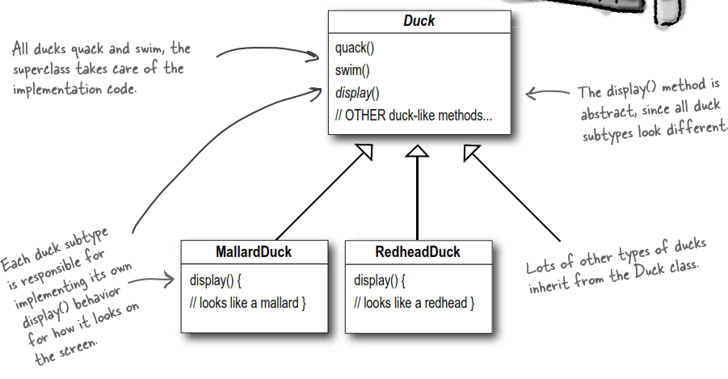

**Issue**: What if adding a new behavior called *fly* for all ducks and add a new duck type called *Rubber* ducks which do NOT either quack (they *squeak* instead) or fly. Keep using ideas of the old design as below? NO!

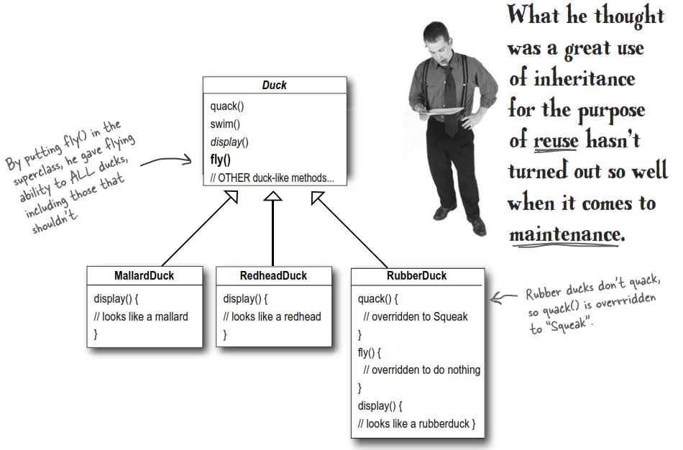

### Poor Design #2

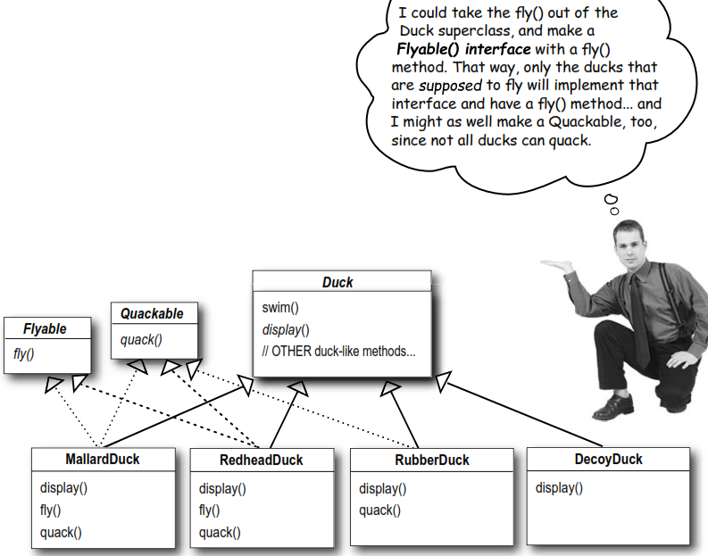

**Issue**: While having the subclasses implement *Flyable* and *Quackable* solves part of the problem (no inappropriately ﬂying rubber ducks), it completely destroys code reuse for those behaviors, so it just creates a different maintenance nightmare. Not to mention that there might be more than one kind of ﬂying behavior even among the ducks that do ﬂy...

### Good Design

**Design Principle 1**: Take the parts that vary and encapsulate them, so that later you can alter or extend them without affecting others.

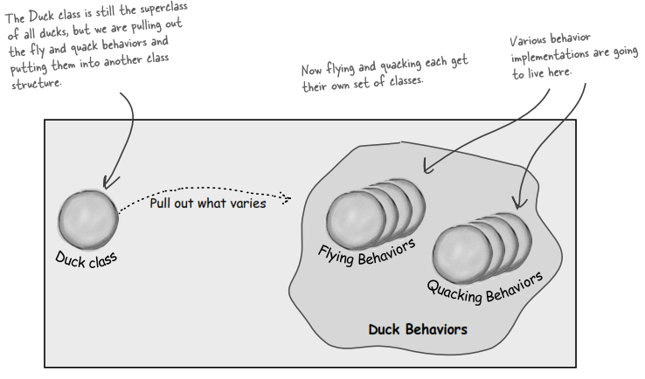

From now on, the *Duck* behaviors will live in a separate class—a class that implements a particular behavior interface. That way, the *Duck* classes won’t need to know any of the implementation details for their own behaviors.

**Design Principle 2:** Program to an interface, not an implementation.

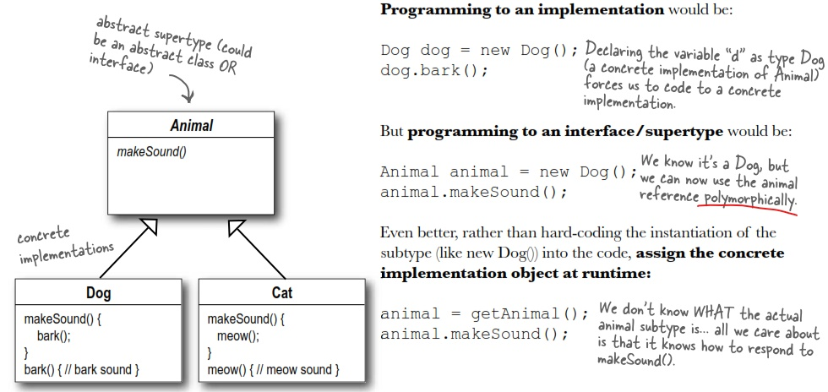

**If your code is written to an interface, it will work with any new class implementing that interface through polymorphism**. By contrast, when you have code that makes use of lots of concrete classes, you’re looking for trouble because that code may have to be changed as new concrete classes are added.

The class diagram for Duck’s behaviors of SimuDuck will look like this:

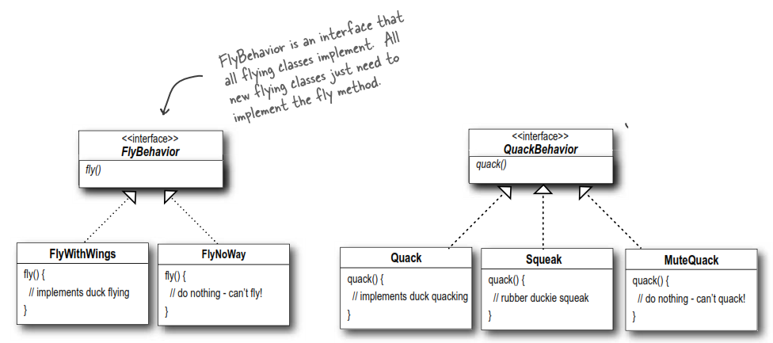

**Design Principle 3**: Favor composition over inheritance.

The **composition** (HAS-A) relationship is an interesting one: each duck has a *FlyBehavior* and a *QuackBehavior* to which it delegates ﬂying and quacking.

As you can see from the SimuDuck project, creating systems using composition gives you a lot more ﬂexibility. Not only does it let you encapsulate a family of duck behaviors into their own set of classes, but it also lets you change these behaviors at runtime as long as the object you’re composing with implements the correct behavior interface.

## Strategy Design Pattern

We will describe things a little differently here. Instead of thinking of the duck behaviors as a set of behaviors, we’ll start thinking of them as a **family of algorithms**.

The Strategy pattern deﬁnes a family of algorithms, encapsulates each one, and makes them interchangeable. Strategy lets the algorithm vary independently from clients that use it.

Full class diagram of SimuDuck project:

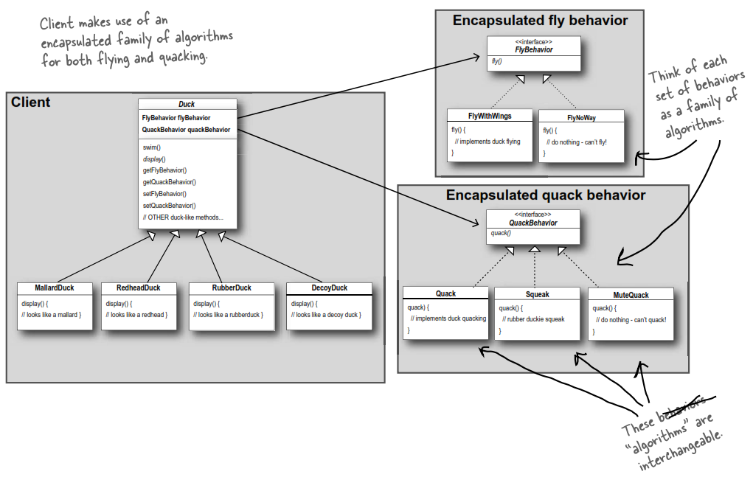

# Observer Design Pattern

## Project and Solution

Weather Monitoring app: Provide 3 display elements, including Current Conditions (shows temperature, humidity, and pressure), Weather Statistics, and a Simple Forecast.

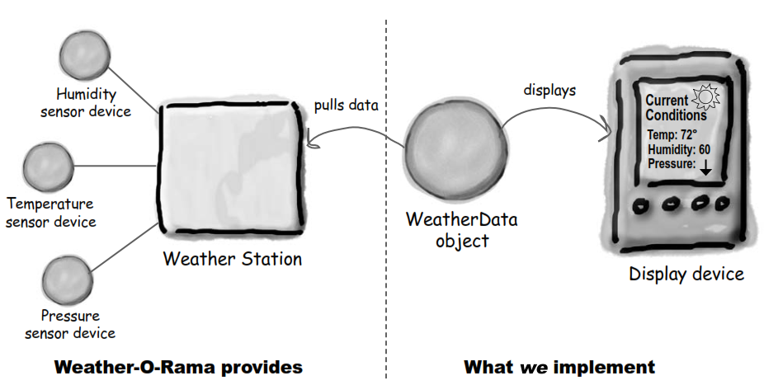

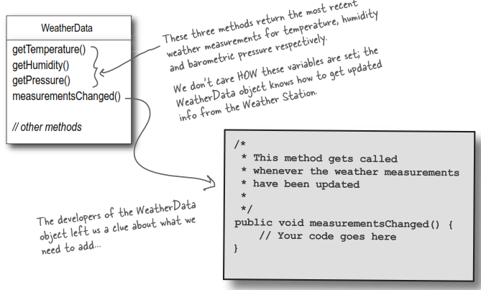

Our job is to implement *MeasurementsChanged()*, so that it updates the three displays for current conditions, weather stats, and forecast.

### Poor Design

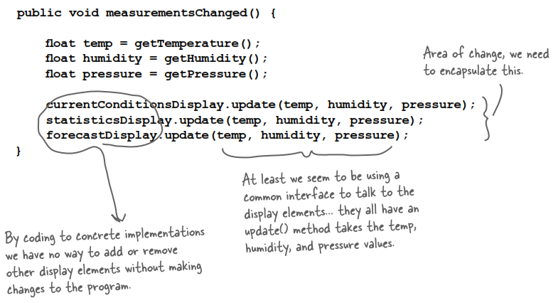

## Observer Design Pattern

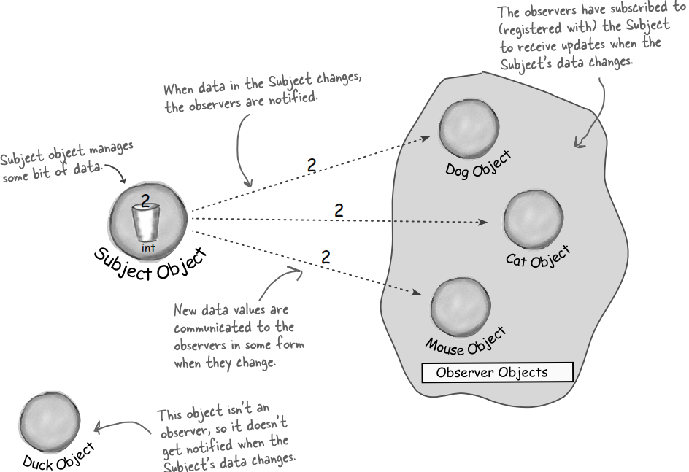

The Observer pattern deﬁnes a one-to-many dependency between objects so that when one object changes state, all of its dependents are notiﬁed and updated automatically.

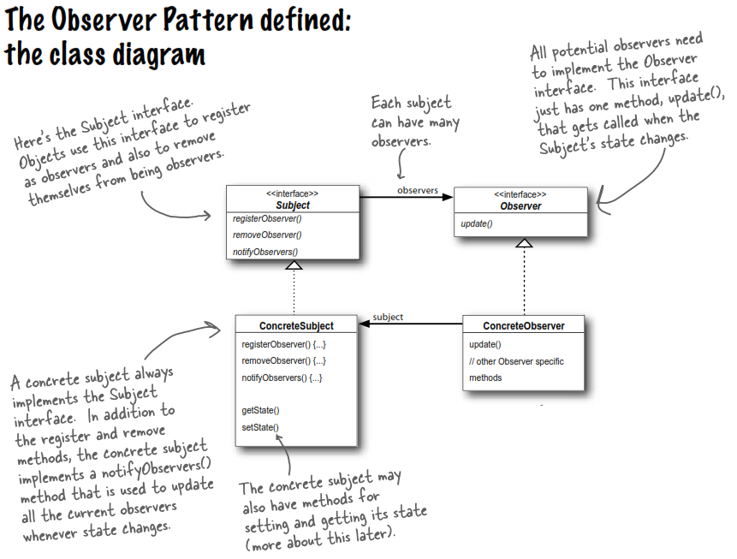

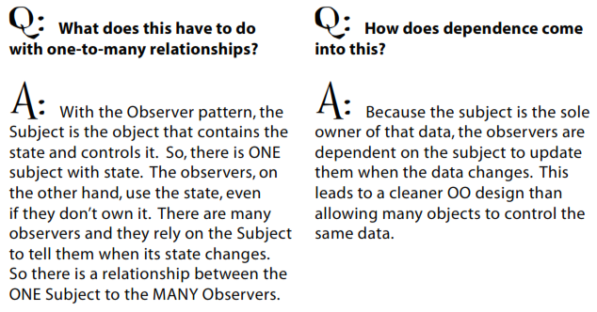

**Back to our Weather Monitoring app:**

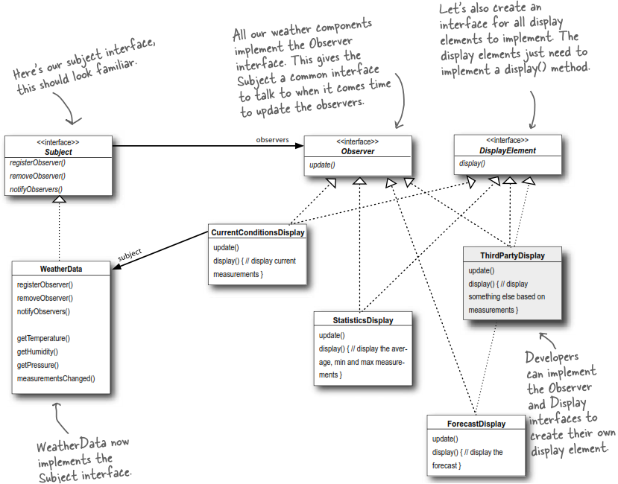

## The Power of Loose Coupling

When two objects are loosely coupled, they can interact, but have very little knowledge of each other.

**The Observer Pattern provides an object design where subjects and observers are loosely coupled**.

Why?

* **The only thing the subject knows about an observer is that it implements a certain interface** (the Observer interface). It doesn’t need to know the concrete class of the observer, what it does, or anything else about it.
* **We can add / remove / replace observers at any time**. Because the only thing the subject depends on is a list of objects that implement the Observer interface, we can add / remove / replace observers whenever we want.
* **We never need to modify the subject to add new types of observers.** Let’s say we have a new concrete class come along that needs to be an observer, all we have to do is implement the Observer interface in the new class and register as an observer. The subject doesn’t care; it will deliver notiﬁcations to any object that implements the Observer interface.
* **We can reuse subjects or observers independently of each other**. If we have another use for a subject or an observer, we can easily reuse them because the two aren’t tightly coupled.
* **Changes to either the subject or an observer will not affect the other**. Because the two are loosely coupled, we are free to make changes to either, as long as the objects still meet their obligations to implement the subject or observer interfaces.

**Design Principle 4**: Strive for loosely coupled designs between objects that interact.

Loosely coupled designs allow us to build ﬂexible OO systems that can handle changes because they minimize the interdependency between objects.

# Decorator Design Pattern

## Project and Solution

Starbuzz Coffee: Application to manage all types of coffee (flavors and prices).

### Poor Design

When Starbuzz ﬁrst went into business, they designed their classes like this:

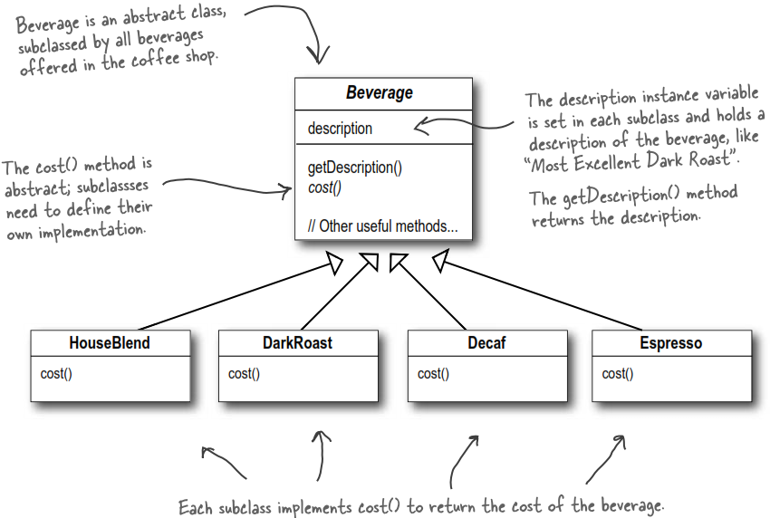

Because customers want more flavors, Starbuzz add many condiments like steamed milk, soy, mocha, etc. So they change their classes a bit:

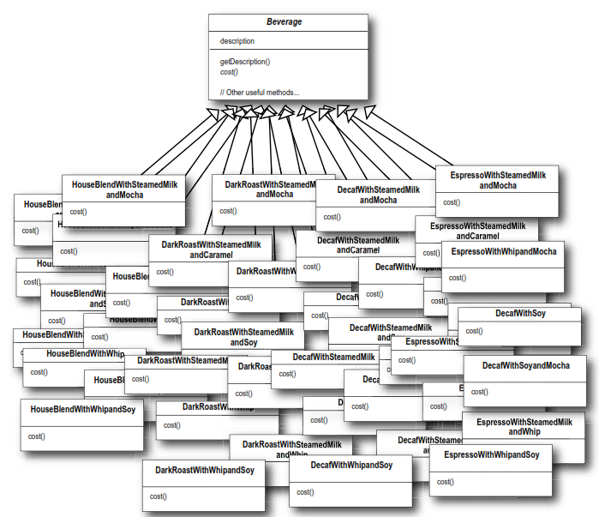

* Class explosion

### Good Design

**Design Principle 5** (Open-Closed): Classes should be open for extension, but closed for modiﬁcation.

**QA:**

1. Open for extension and closed for modiﬁcation? That sounds very contradictory. How can a design be both?

* There are some clever OO techniques that allow systems to be extended, even if we can’t change the underlying code. Think about the Observer Pattern; by adding new Observers, we can extend the Subject at any time, without adding code to the Subject.

You’ll see quite a few more ways of extending behavior with Decorator and other OO design techniques.

1. How can I make every part of my design follow the Open-Closed Principle?

* Usually, you can’t. And you shouldn’t! Following the Open-Closed Principle usually introduces new levels of abstraction, which adds complexity to our code.

You want to **concentrate on those areas that are most likely to change in your designs and apply the principles there**.

## Decorator Design Pattern

Okay, we’ve seen that representing our beverage with inheritance has not worked out very well – we get class explosions, rigid designs, or we add functionality to the base class that isn’t appropriate for some of the subclasses.

So, here’s what we’ll do instead: we’ll **start with a beverage and “decorate” it with the condiments at runtime**. For example, if the customer wants a Dark Roast with Mocha and Whip, then we’ll:

1. Take a *DarkRoast* object
2. Decorate it with a *Mocha* object
3. Decorate it with a *Whip* object
4. Call the cost() method and rely on delegation to add on the condiment costs

|  |  |
| --- | --- |
|  |  |

The implementation would be:

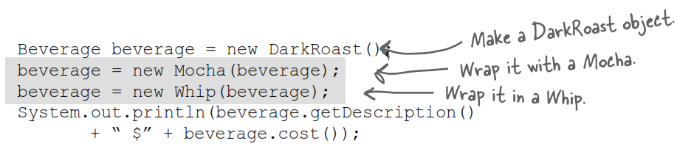

Okay, here’s what we know so far;

* **Decorators have the same supertype as the objects they decorate**.
* Decorator classes mirror the type of the components they decorate. (In fact, they are the **same supertype as the objects they decorate, either through inheritance or interface.**)
* **You can use one or more decorators to wrap an object**.
* Given that the decorator has the same supertype as the object it decorates, we can pass around a decorated object in place of the original (wrapped) object.
* **The decorator adds its own behavior either before and/or after delegating to the object it decorates to do the rest of the job**.
* Objects can be decorated at any time, so we can decorate objects dynamically at runtime with as many decorators as we like.

**The Decorator Pattern defined:**

The Decorator pattern attaches additional responsibilities to an object dynamically. Decorators provide a ﬂexible alternative to subclassing for extending functionality.

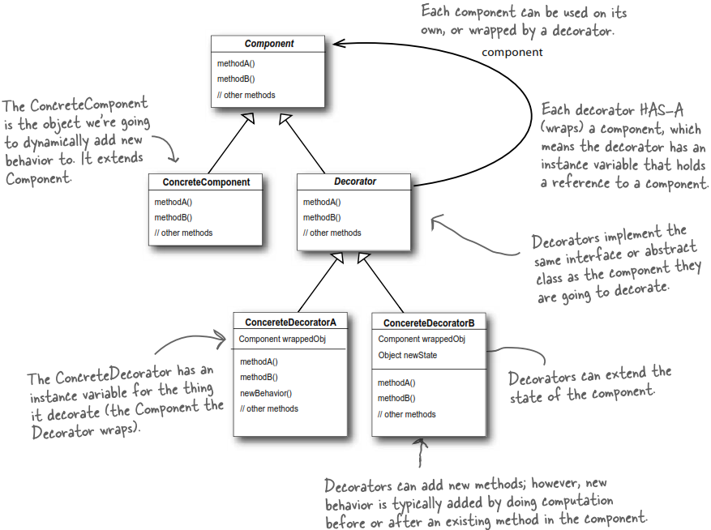

**Back to our Starbuzz project:**

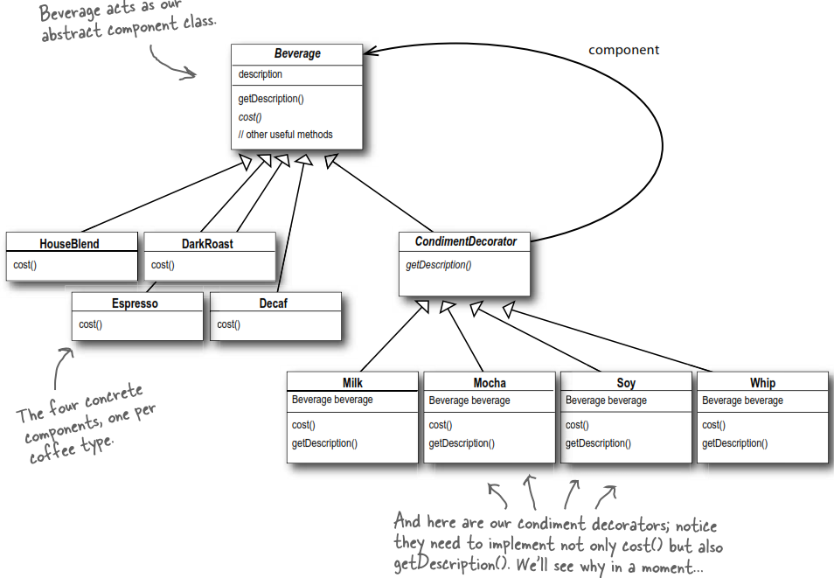

# Factory Method + Abstract Factory Design Pattern

## Project and Solution

You have a pizza shop, called PizzaStore.

After adding some code that determines the appropriate type of pizza, you go about making the pizza. But then you realize that your competitors have added a couple of trendy pizzas to their menus. So you decide to add these items to your menu. At the same time, you want to remove some pizzas with bad sales.

### Poor Design

You come up with the code like this:

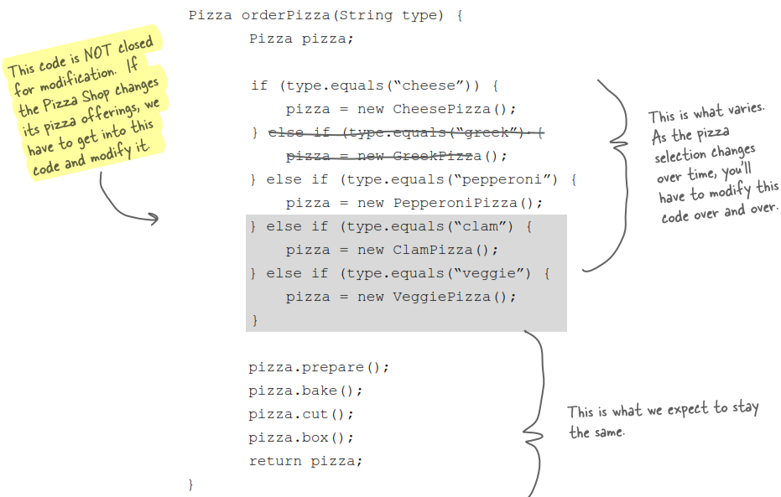

Clearly, dealing with which concrete class is instantiated is really messing up our orderPizza() method and preventing it from being closed for modiﬁcation. But now we know what is varying and what isn’t, it’s time to encapsulate it.

### Good Design: Simple Factory

We move the object creation out of the orderPizza() method.

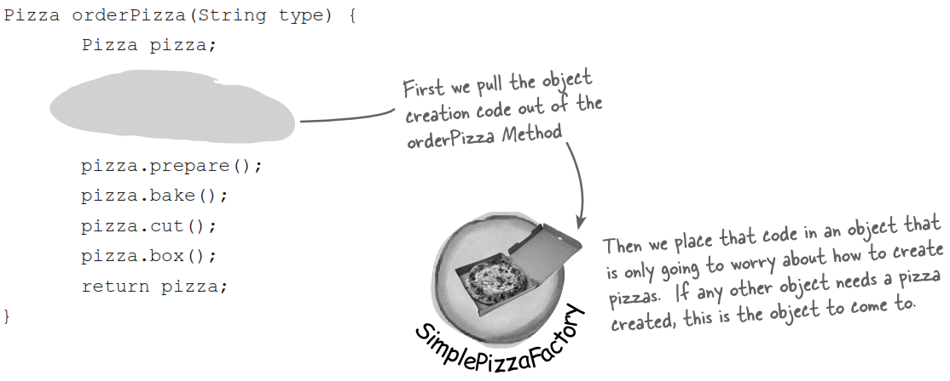

We call it the ***Factory* which handles the details of object creation**. Once we have a SimplePizzaFactory class, our orderPizza() method just becomes a client of that object. Any time it needs a pizza, it asks the factory to make one.

By encapsulating the pizza creating in one class, **we now have only one place to make modifications when the implementation changes**. Another advantage is that the SimplePizzaFactory may have many clients, and all of them can call SimplePizzaFactory with ease.

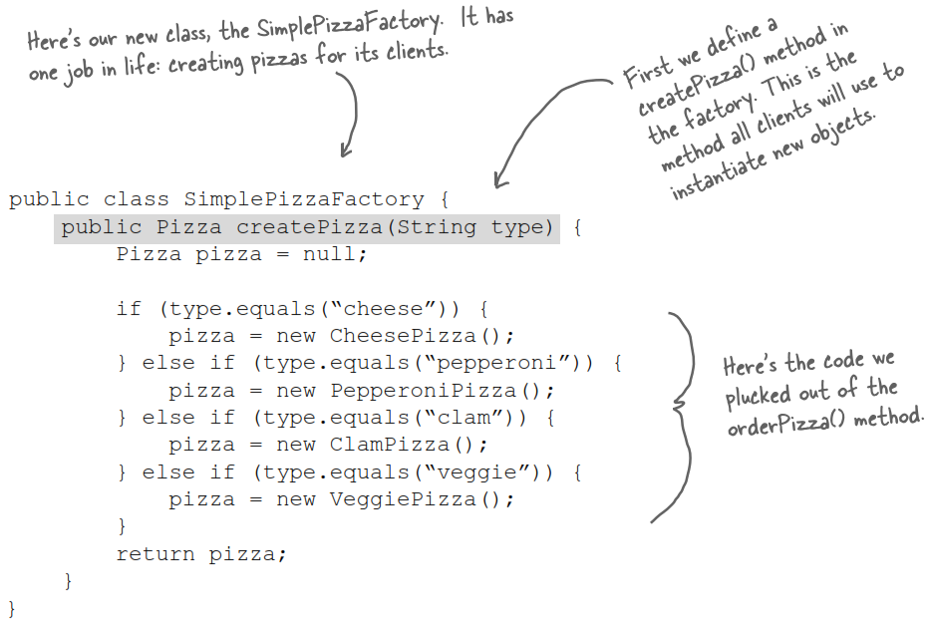

Class diagram of our new Pizza Store:

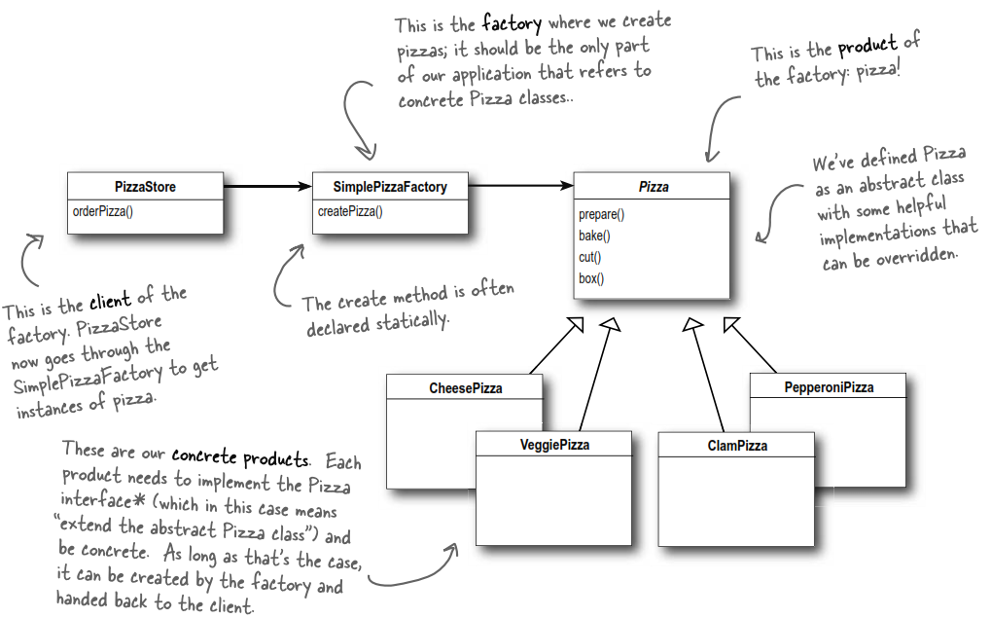

### Best Design: Factory Method

Your local PizzaStore has done so well that now everyone wants a PizzaStore in their own neighborhood. But the point is that each franchise might want to offer different styles of pizzas (New York, Chicago, and California), depending on where the franchise store is located and the tastes of the local pizza connoisseurs. What should you do now?

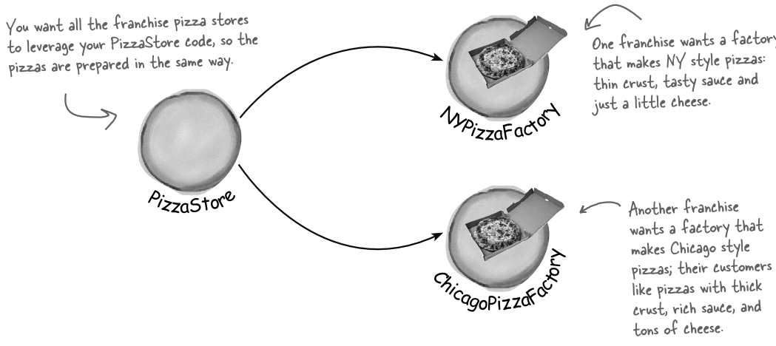

In the Simple Factory design, we create the SimplePizzaFactory class to handle creating pizzas and put the createPizza() method to it.

Now what we’re going to do is putting the createPizza() method back into PizzaStoreclass, but this time as an **abstract method**, and then create a **PizzaStore subclass for each regional style.

**Design Principle 5** (Dependency Inversion): Depend upon abstractions. Do not depend upon concrete classes.

Let’s look at these changes:

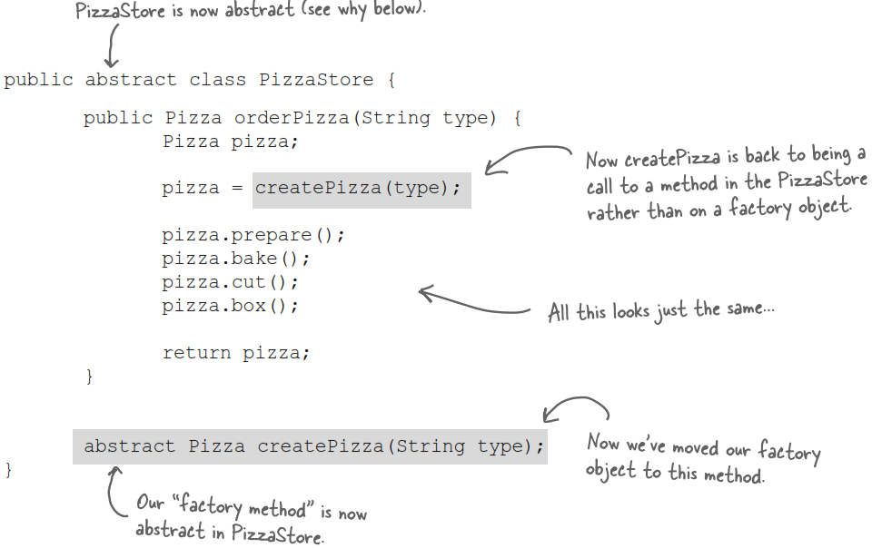

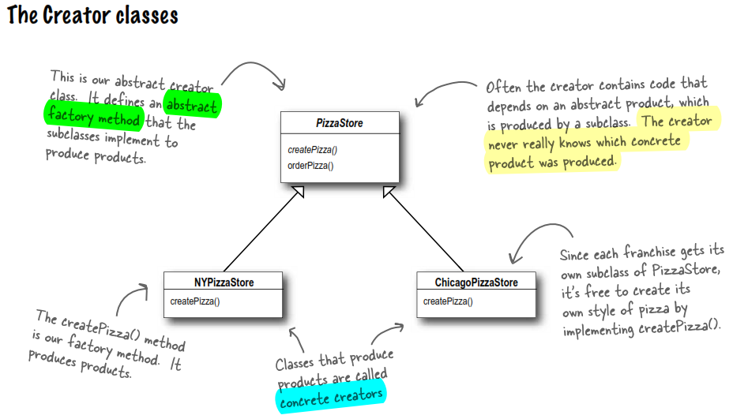

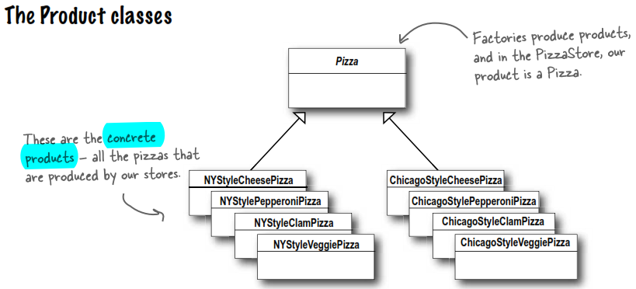

## Factory Method Design Pattern

The Factory Method pattern deﬁnes an interface for creating an object, but lets subclasses decide which class to instantiate.

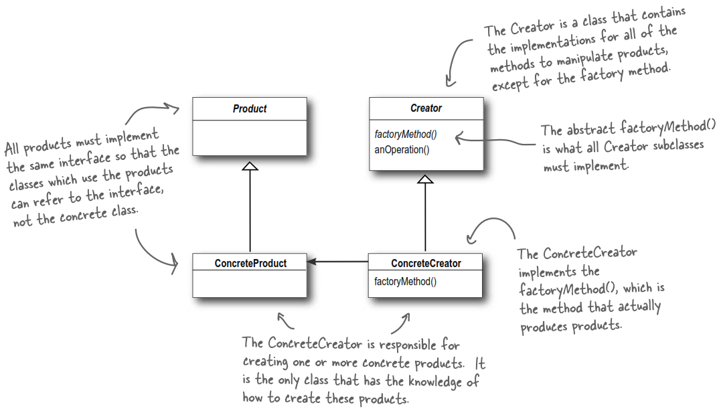

**QA**

I’m a bit confused about the difference between **Simple Factory** and **Factory Method**. They look very similar, except that in Factory Method, the class that returns the pizza is a subclass. Can you explain?

* You’re right that these two designs are similar; however, think of Simple Factory as a one-shot deal, while Factory Method creates a framework that lets the subclasses decide which implementation will be used.

For example, in the Factory Method, you decide what concrete products go into making the pizza that orderPizza() returns. Compare that with Simple Factory, which gives you a way to encapsulate object creation, but doesn’t give you the flexibility of the Factory Method because there is no way to vary the products you’re creating.

## Abstract Factory Design Pattern

The Abstract Factory Pattern provides an interface for **creating families of related or dependent objects without specifying their concrete classes**.

**Factory Method:**

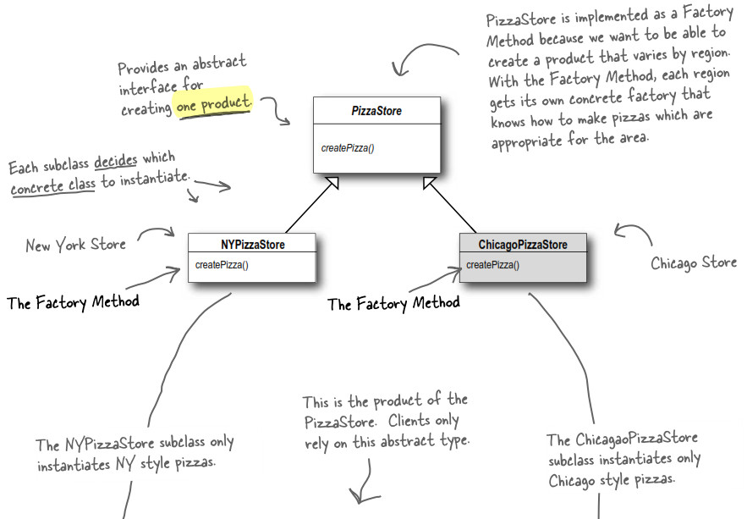

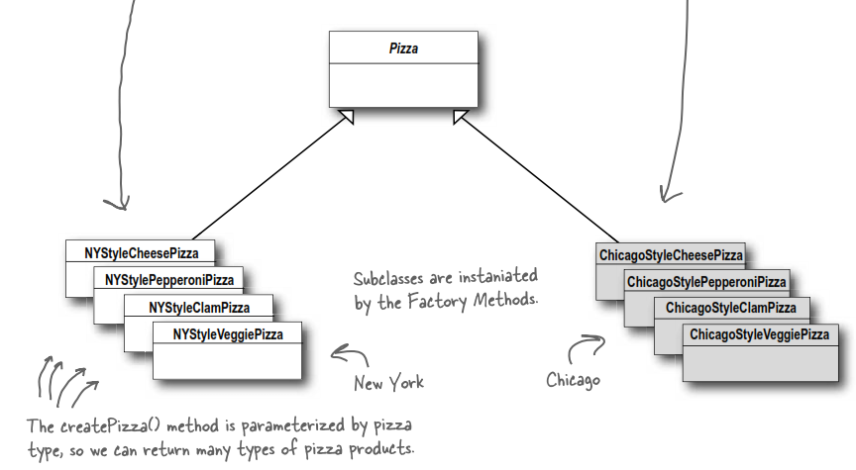

**Abstract Factory:**

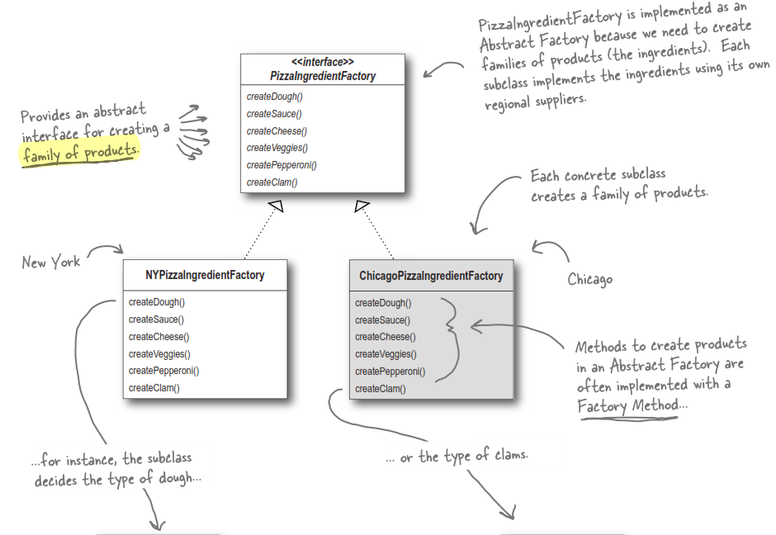

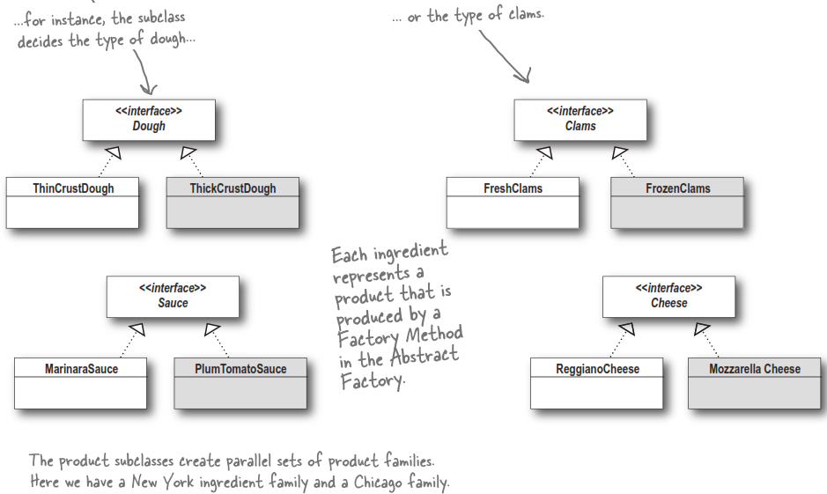

## Why Abstract Factory?

* It **ensures that the right concrete objects are created** throughout a system. You don't want a ThickCrustDough to appear on a NYPizzaIngredientFactory; you can use the Abstract Factory to ensure that a ThickCrustDough can appear only on a ChicagoPizzaIngredientFactory. The rest of the application works with the abstract types Pizza.
* It **keeps all the details of creating objects in one place**.
* It **enfores the consistency of object creation** because the application uses mFactory as the only object creator.

## Generic Abstract Factory

# Singleton Design Pattern

## Why Singleton?

*Guru*: There are many objects we only need one of: thread pools, caches, dialog boxes, objects that handle preferences and registry settings, objects used for logging, and objects that act as device drivers to devices like printers and graphics cards. In fact, for many of these, if we were to instantiate more than one we’d run into all sorts of problems like incorrect program behavior, overuse of resources, or inconsistent results.

*Developer*: Can you explain more?

*Guru*: There is power in ONE. Let’s say you have an object that contains registry settings. You don’t want multiple copies of that object and its values running around – that would lead to chaos. By using an object like me you can assure that every object in your application is making use of the same global resource.

*Developer*: So there are classes that should only be instantiated once, but can’t I just do this by ***global variables***? You know, like in C++ or Java, I could do it with a static variable.

Guru: The **Singleton Pattern is a time-tested method for ensuring only one object gets created (in its first call)**. It also gives us a **global access**, just like a global variable, but without the downsides.

*Developer*: What downsides?

*Guru*: For example, if you assign an object to a global variable, then that object might be created when your application begins. What what if this object is resource intensive and your application never ends up using it? As you will see, with the Singleton Pattern, we can **create our objects only when they are needed**.

## How Singleton?

// C++

class Singleton {

public:

static Singleton* getInstance() {

if (mInstance == NULL) {

mInstance = new Singleton();

}

return mInstance;

}

static void releaseInstance() {

if (mInstance != NULL) {

delete mInstance;

mInstance = NULL;

}

}

void func() { … }

private:

static Singleton* mInstance; // Unique point of access

Singleton() {} // Prevent clients from creating a new Singleton

~Singleton() {} // and also from deleting the old object

};

Singleton* Singleton::mInstance = NULL;

int main() {

...

Singleton* singleton = Singleton::getInstance(); // The only way to get object

singleton->func();

...

Singleton::releaseInstance(); // Maybe in another file

return 0;

}

Singleton definition:

**The Singleton Pattern ensures a class has only one instance, and provides a unique global point of access to it.**

Let’s break it down a bit more:

1. We’re taking a class and letting it manage (create and destroy) a single instance of itself. With a private default constructor (and maybe a *copy constructor*, *assignment operator*, *copy assignment operator*), we **prevent client code and any other class from creating a new instance** on its own during compiling time. To get an instance, you’ve got to go through the class itself.
2. We’re also providing a **global access to the instance**: whenever you need an instance, just query the class and it will hand you back the single instance. For global resources in our program, this approach is really effective.
3. If it's **never used (no call to getInstance method), the Singleton object is not created**. So we have both protection and optimization.

## Reference for Singleton?

The common way of implementing Singleton design pattern is to have getInstance() return a pointer. But we can actually allow getInstance() to return a reference instead.

In fact, using reference has an advantage over pointer. The problem with having instance return a pointer is that callers might be tempted to delete it. To minimize the chances of that happening, it's safer to return a reference:

class Singleton {

public:

static Singleton& Singleton::getInstance() {

if (mInstance == NULL) {

mInstance = new Singleton();

}

return *mInstance;

}

...

private:

static Singleton* mInstance;

## Multithread in Singleton

In a multithread application, Singleton has to deal with threads. Take the above getInstance() as an example. Suppose two threads access it. The 1st thread enters getInstance() and tests the if condition. Because it's the very first access, mInstance is NULL, and the thread reaches the next line and is ready to call the new operator.

It might just happen that the OS scheduler unwittingly interrupts the first thread at this point and passes control to the other thread. The 2nd thread enters the stage, call getInstance(), and finds a NULL mInstance as well because the 1st thread hasn't yet had a chance to modify it. Now say the 2nd thread manages to call the new operator, assigns mInstance in peace, and gets away with it. Unfortunately, the 1st thread remembers it was just about to execute line 2, so it reassigns mInstance and gets away with it, too.

When the dust settles, there are two Singleton objects instead of one, and one of them will leak for sure. Also, the application is surely slipping toward chaos.

**A Singleton object is a shared global resource, and all shared global resources are always suspect for multithreading issues.**

Check ***Double-Checked Locking pattern*** (sec 6.9.1, C++ Design Generic Programming and Design Patterns Applied - By Andrei Alexandrescu) or [Thread-Safe Initialization of a Singleton](https://www.modernescpp.com/index.php/thread-safe-initialization-of-a-singleton)

## Notes When Using Singleton

**Do NOT make all methods static**

In Singleton, only getInstance and releaseInstance methods and object references are static. Other methods should be non-static simply because they do not have to be static for a Singleton to work. Check [disadvantage of static methods](https://r.je/static-methods-bad-practice).

**What if Singleton object is not released?**

Understand that memory leaks only appear when you allocate accumulating data and lose all references to it.

With Singleton, in most cases, if its object is not deleted, that's not a memory leak. Nothing is accumulating, and we hold knowledge about the allocated memory until the end of the application. Furthermore, all modern operating systems take care of completely deallocating a process's memory upon termination.

However, there are cases when memory leaks actually happen: a **resource leak**. Singleton's constructor may acquire an unbound set of resources: network connections, handles to OS-wide mutexes and other interprocess communication means, references to out-of-process CORBA or COM objects, and so on.

So for the best practive, releasing Singleton object after it’s was used is a should. To do that, we have two ways:

* Manually release the object. Of course, we have to choose the moment carefully so that no one tries to access the singleton after its destruction.
* Let the system automatically releases the object during the application's shutdown. Read ***Meyers Singleton*** (sec 6.4, C++ Design Generic Programming and Design Patterns Applied - By Andrei Alexandrescu) for how to do that.

# Adapter Design Pattern

## What Is Real-World Adapter?

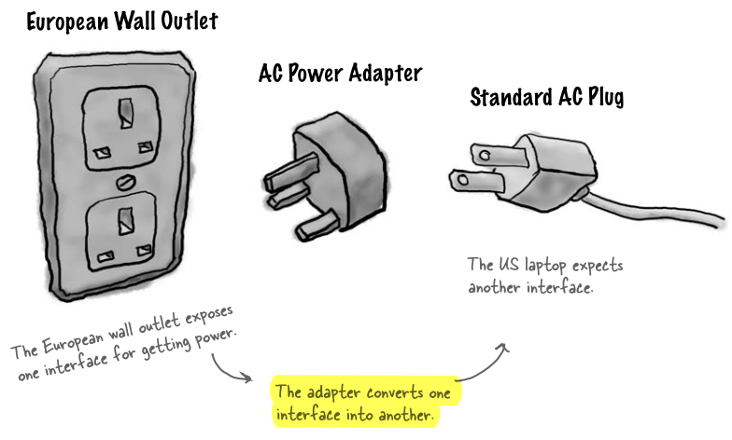

The adapter changes the interface of the outlet into one that your laptop expects.

## What Is Object-Oriented Adapter?

Say you’ve got an existing software system that you need to work a new vendor class library into, but the new vendor designed their interfaces differently than the last one:

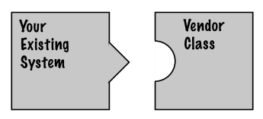

Okay, you don’t want to solve the problem by changing your existing code (and you can’t change the vendor’s code). So what do you do? Well, you can write a class that adapts the new vendor interface into the one you’re expecting.

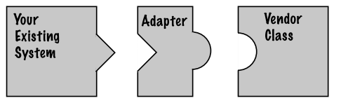

The adapter acts as the middleman by receiving requests from the client and converting them into requests that make sense on the vendor classes.

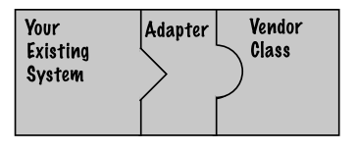

**The Adapter Pattern converts the interface of a class into another interface the clients expect. Adapter lets classes work together that couldn’t otherwise because of incompatible interfaces.**

**Example:**

|  |  |
| --- | --- |
|  |  |

* What we just do is: converting *Turkey* interface to *Duck* interface.

## Object Adapter and Class Adapter

There are actually two kinds of adapters: **Object Adapter** and **Class Adapter**.

**Object Adapter’s class diagram:**

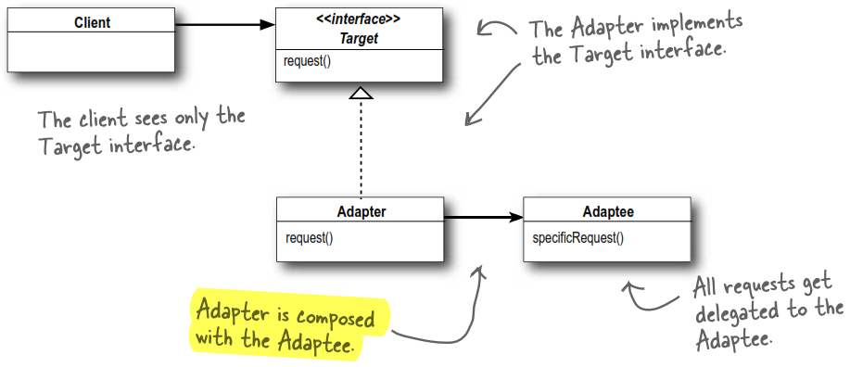

**Class Adapter’s class diagram:**

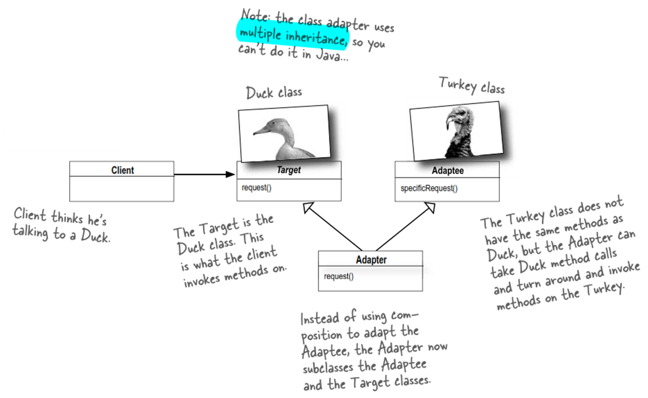

**Conversation:**

***Object Adapter:*** *Because I use composition I’ve got a leg up. I cannot only adapt an adaptee class, but any of its subclasses.*

***Class Adapter:*** *That’s true, I do have trouble with that because I am committed to one speciﬁc adaptee class, but I have a huge advantage because I don’t have to re-implement my entire adaptee. I can also override the behavior of my adaptee if I need to because I’m just subclassing.*

***Object Adapter:*** *In my part of the world, we like to use composition over inheritance; you may be saving a few lines of code, but all I’m doing is writing a little code to delegate to the adaptee. We like to keep things ﬂexible.*

***Class Adapter:*** *Flexible maybe, efﬁcient? No. Using a class adapter there is just one of me, not an adapter and an adaptee.*

***Object Adapter:*** *You’re worried about one little object? You might be able to quickly override a method, but any behavior I add to my adapter code works with my adaptee class and all its subclasses.*

***Class Adapter:*** *Yeah, but what if a subclass of adaptee adds some new behavior. Then what?*

*Object Adapter: Hey, come on, cut me a break, I just need to compose with the subclass to make that work.*

***Class Adapter:*** *Sounds messy...*

***Object Adapter:*** *You wanna see messy? Look in the mirror!*

# Facade Design Pattern

## Project and Solution

Build a Home Theater

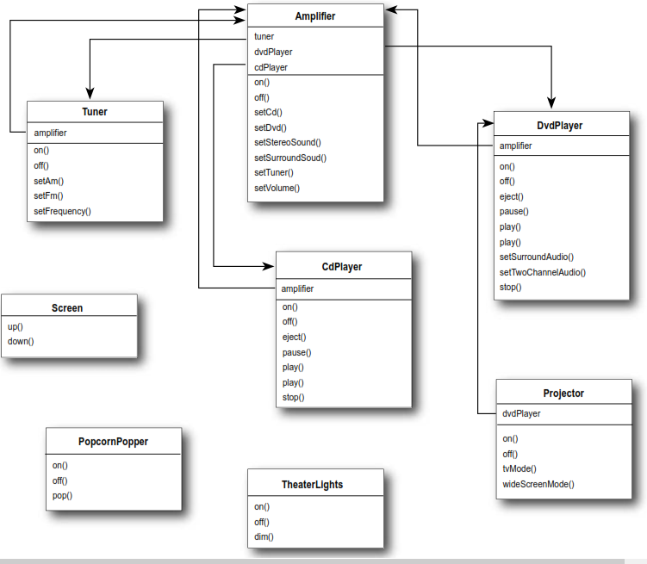

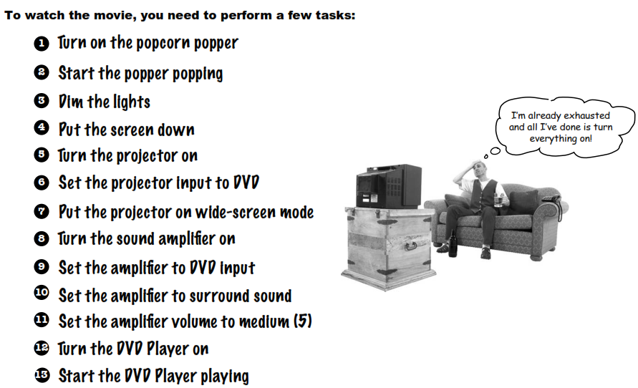

### Poor Design

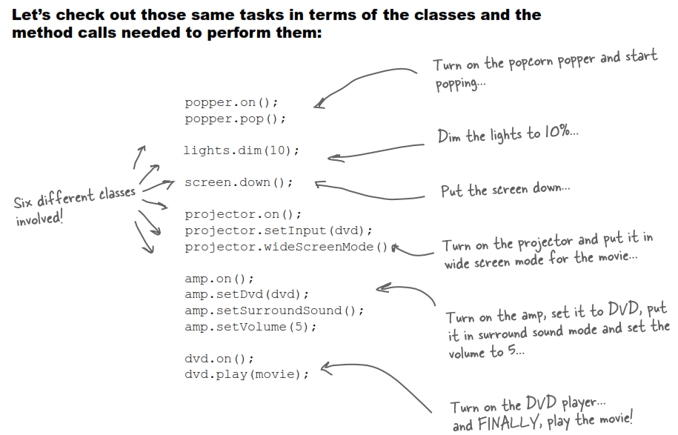

**Issue**: So you **have to call lots of methods in numerous classes** --> Big headache! Also, when the movie is over, how do you turn everything off? Nooooooooo!

### Good Design

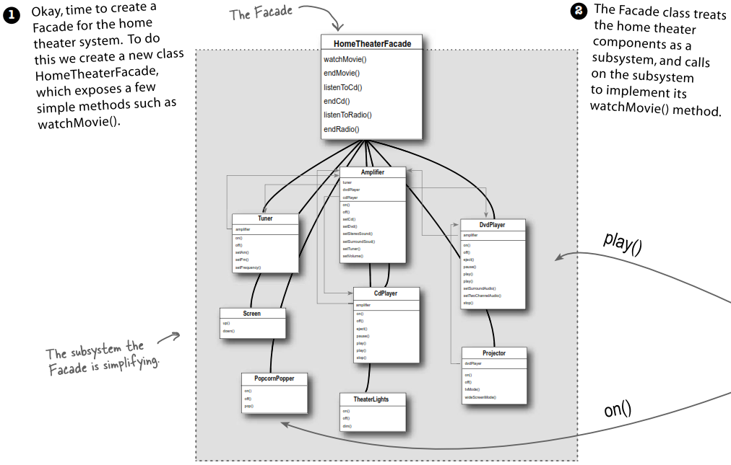

|  |  |
| --- | --- |
|  |  |

## Facade Design Pattern

**The Facade Pattern provides a uniﬁed interface to a set of interfaces in a subsystem. Facade deﬁnes a higher level interface that makes the subsystem easier to use.**

Class diagram:

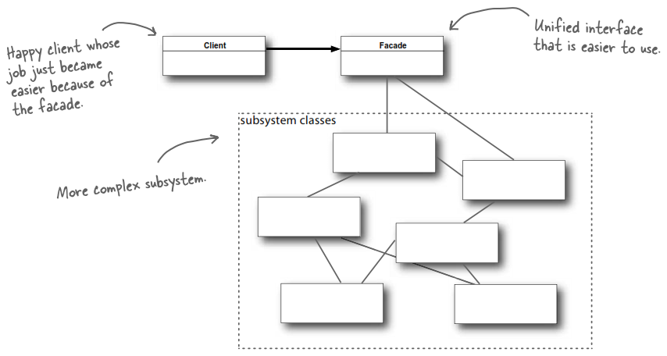

**Design Principle 6** (Least Knowledge): Talk only to your immediate friends.

It means when you are designing a system, for any object, be careful of the number of classes it interacts with and also how it comes to interact with those classes.

This principle prevents us from creating designs that have a large number of classes coupled together so that changes in one part of the system cascade to other parts. When you build a lot of dependencies between many classes, you are building a fragile system that will be costly to maintain and complex for others to understand.

# Template Method Pattern

## Project and Solution

BeverageMaking: including coffee and tea. They are made in pretty similar ways.

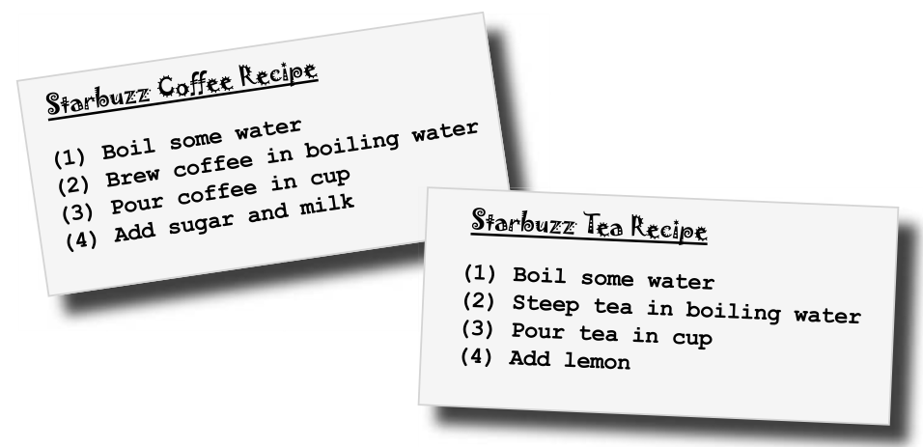

### Bad Design

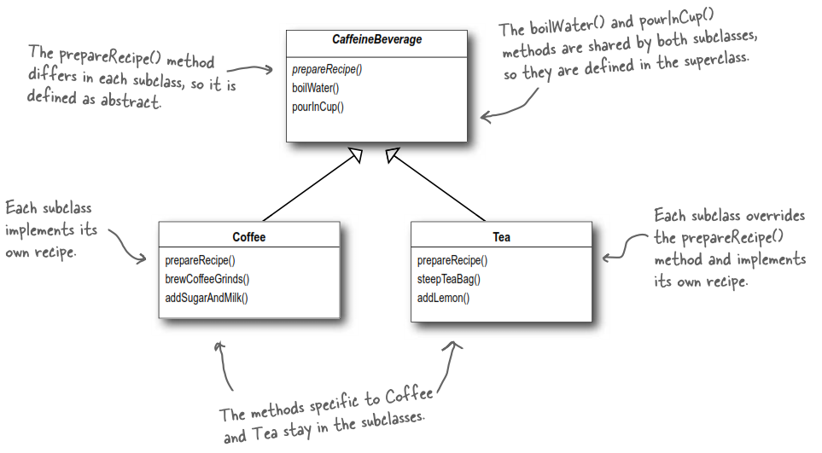

### Good Design

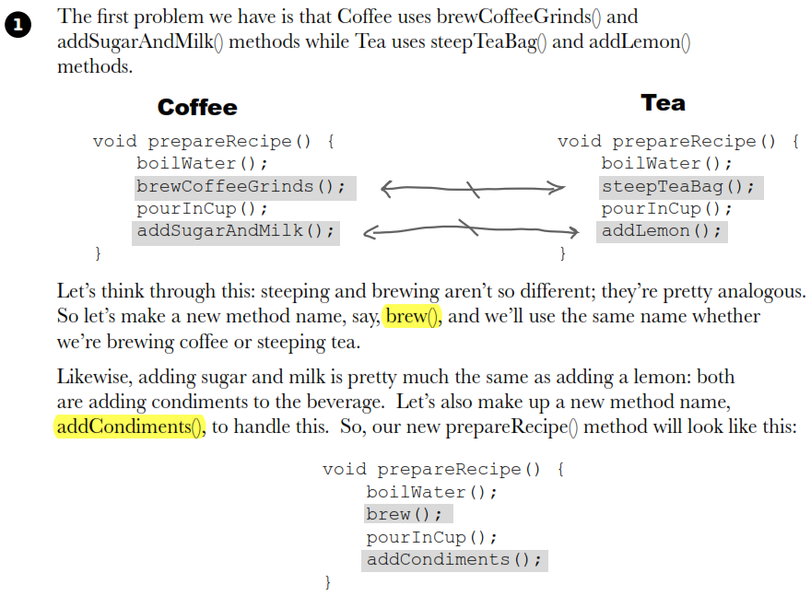

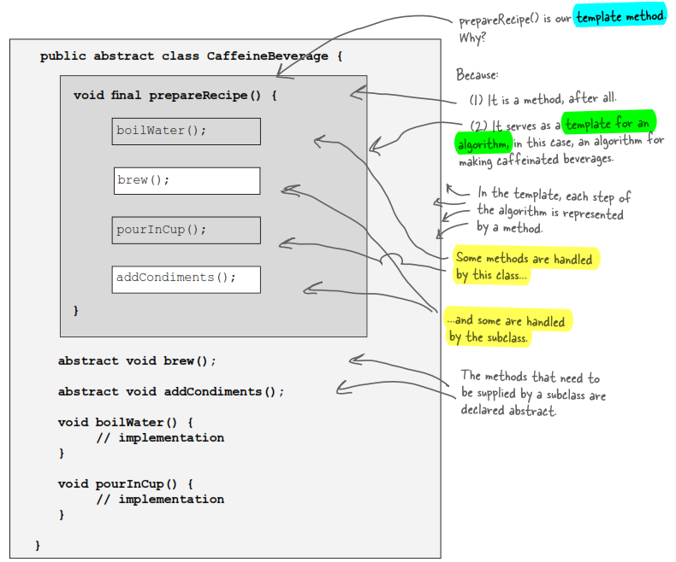

|  |  |
| --- | --- |
| **Bad design** | **Good design** |
| Knowledge of the algorithm and how to implement it is distributed over many classes. | The *CaffeineBeverage* class concentrates knowledge about the algorithm and relies on subclasses to provide complete implementations. |
| Code changes to the algorithm require opening the subclasses and making multiple changes. | The algorithm lives in one place and code changes only need to be made there. |
| Classes are organized in a structure that requires a lot of work to add a new caffeine beverage. | The Template Method version provides a framework that other caffeine beverages can be plugged into. New caffeine beverages only need to implement a couple of methods. |

## Template Design Pattern

The Template Method Pattern deﬁnes the skeleton of an algorithm in a method, deferring some steps to subclasses. Template Method lets subclasses redeﬁne certain steps of an algorithm without changing the algorithm’s structure.

## Hooks in Template Design Pattern

So far, all subclasses must follow exactly the algorithm defined in *prepareRecipe()* in the base class. What if one of these subclasses needs to change the algorithm a bit (e.g. skip/add a step from the algorithm) to fit its own purpose?

* Use a ***Hook***

A hook is a **method** that is declared in the abstract class (same class as the Template method). A special thing about the hook is that it’s only given an **empty or default implementation**. This gives subclasses the ability to “hook into” the algorithm at various points.

Besides, with the hook, a subclass can override the method, or not; it’s its choice. If it doesn’t, the abstract class provides a default implementation.

|  |  |
| --- | --- |
|  |  |

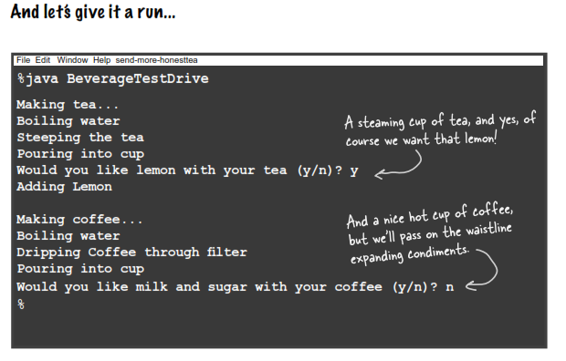

**Q**: What are hooks really supposed to be used for?

**A**: There are a few uses of hooks. As we just said, a hook may provide a way for a subclass to implement an **optional part** of an algorithm, or if it isn’t important to the subclass’ implementation, it can skip it.

Another use is to give the subclass a chance to react to some steps in the template method that is about to happen, or just happened. For instance, a hook method like *justReOrderedList()* allows the subclass to perform some activity (such as redisplaying an onscreen representation) after an internal list is reordered. As you’ve seen, a hook can also provide a subclass with the ability to make a decision for the abstract class.

**Design Principle 7** (Hollywood Principle): Don’t call us, we’ll call you.

With the Hollywood Principle, we **allow low-level components to hook themselves into a system, but the high-level components determine when they are needed and how**. In other words, the high-level components give the low-level components a “don’t call us, we’ll call you” treatment.

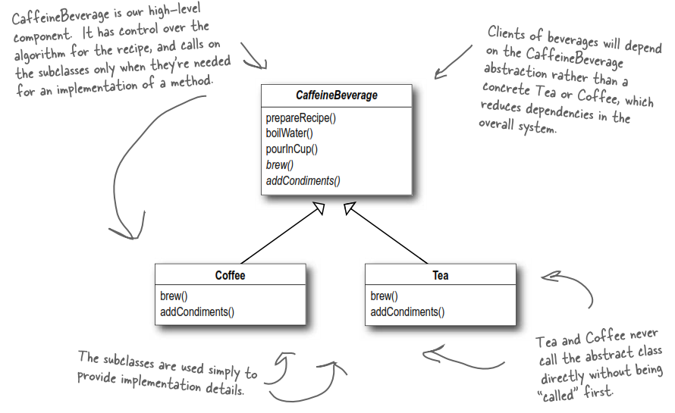

# Iterator Design Pattern

## Project and Solution

The client wants to have both delicious pancake breakfasts at the *Pancake House* and yummy lunches at the *Diner* all in one place for their party.

But, there is a slight problem on the way each menu is implemented. Pancake House uses an *ArrayList* to hold its menu items, while Diner uses an *Array*.

Our project should have following output:

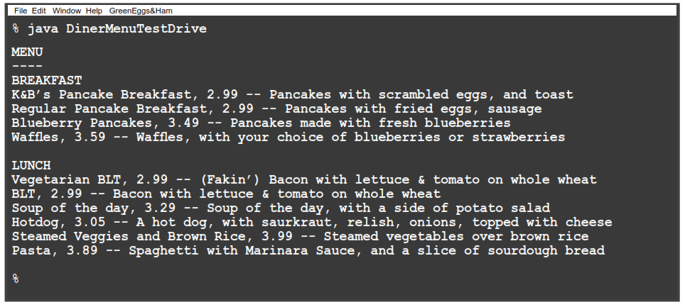

Let’s take a look at the current implementation that we already have:

// Java code

public class MenuItem

{

String name;

String description;

boolean vegetarian;

double price;

public MenuItem(String name, String description, boolean vegetarian, double price) {

this.name = name;

this.description = description;

this.vegetarian = vegetarian;

this.price = price;

}

public String getName() {

return name;

}

public String getDescription() {

return description;

}

public double getPrice() {

return price;

}

public boolean isVegetarian() {

return vegetarian;

}

}

// PancakeHouseMenu

public class PancakeHouseMenu implements Menu

{

ArrayList menuItems; // Array list

public PancakeHouseMenu() {

menuItems = new ArrayList();

addItem("K&B's Pancake Breakfast", "Pancakes with scrambled eggs, and toast",

             true, 2.99);

addItem("Regular Pancake Breakfast", "Pancakes with fried eggs, sausage",

             false, 2.99);

addItem("Blueberry Pancakes", "Pancakes made with fresh blueberries",

             true, 3.49);

addItem("Wafﬂes", "Wafﬂes, with your choice of blueberries or strawberries",

             true, 3.59);

}

public void addItem(String name, String description, boolean vegetarian, double price) {

MenuItem menuItem = new MenuItem(name, description, vegetarian, price);

menuItems.add(menuItem);

}

public ArrayList getMenuItems() {

return menuItems;

}

    // other menu methods here

}

// DinerMenu

public class DinerMenu implements Menu

{

static ﬁnal int MAX_ITEMS = 6;

int numberOfItems = 0;

MenuItem[] menuItems; // Array

public DinerMenu() {

menuItems = new MenuItem[MAX_ITEMS];

addItem("Vegetarian BLT", "(Fakin') Bacon with lettuce & tomato on whole wheat",

true, 2.99);

addItem("BLT", "Bacon with lettuce & tomato on whole wheat",

false, 2.99);

addItem("Soup of the day", "Soup of the day, with a side of potato salad",

false, 3.29);

addItem("Hotdog", "A hot dog, with saurkraut, relish, onions, topped with cheese"

false, 3.05);

// a couple of other Diner Menu items added here

}

{

public void addItem(String name, String description, boolean vegetarian, double price)

{

MenuItem menuItem = new MenuItem(name, description, vegetarian, price);

if (numberOfItems >= MAX_ITEMS) {

System.err.println("Sorry, menu is full! Can't add item to menu");

} else {

menuItems[numberOfItems] = menuItem;

numberOfItems = numberOfItems + 1;

}

}

public MenuItem[] getMenuItems() {

return menuItems;

}

// other menu methods here

}

### Bad Design

To see why having two different menu representations complicates things, let’s try implementing a client that uses the two menus. Let’s call this client as a *Waitress*.

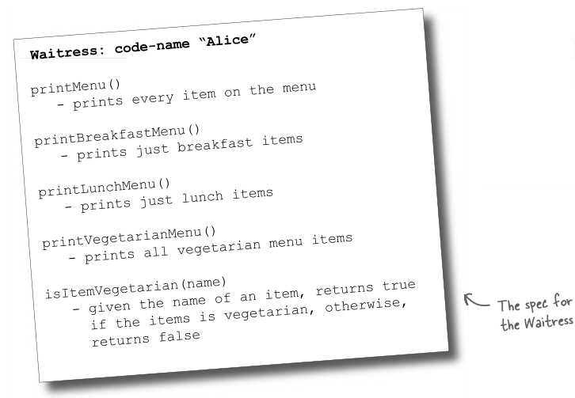

Let’s start by stepping through how we’d implement the printMenu() method:

// DinerMenu

// Get items in PancakeHouseMenu

PancakeHouseMenu pancakeHouseMenu = new PancakeHouseMenu();

ArrayList breakfastItems = pancakeHouseMenu.getMenuItems();

for (int i = 0; i < breakfastItems.size(); i++) {

MenuItem menuItem = (MenuItem)breakfastItems.get(i);

System.out.print(menuItem.getName() + " ");

System.out.println(menuItem.getPrice() + " ");

System.out.println(menuItem.getDescription());

}

// Get items in DinerMenu

DinerMenu dinerMenu = new DinerMenu();

MenuItem[] lunchItems = dinerMenu.getMenuItems();

for (int i = 0; i < lunchItems.length; i++) {

MenuItem menuItem = lunchItems[i];

System.out.print(menuItem.getName() + " ");

System.out.println(menuItem.getPrice() + " ");

System.out.println(menuItem.getDescription());

}

This design is poor because:

* We are coding to the concrete implementations (*PancakeHouseMenu*, *DinerMenu*), not to an interface (*Menu*).
* If we decided to switch from using *DinerMenu* to another type of menu that implemented its list of menu items with a Hashtable, we’d have to modify a lot of code in the *Waitress*.
* The *Waitress* needs to know how each menu represents its internal collection of menu items. This violates encapsulation.
* We have duplicate code: the printMenu() method needs two separate loops to iterate over the two different kinds of menus. And if we added a third menu, we’d have yet another loop.
* The implementation isn’t based on MXML (Menu XML) and so isn’t as interoperable as it should be.

### Good Design

We create a class named **Iterator** which encapsulates the way we iterate through a collection of objects:

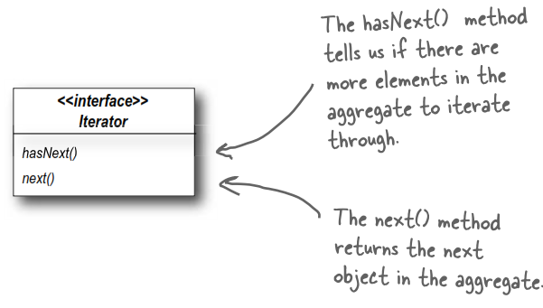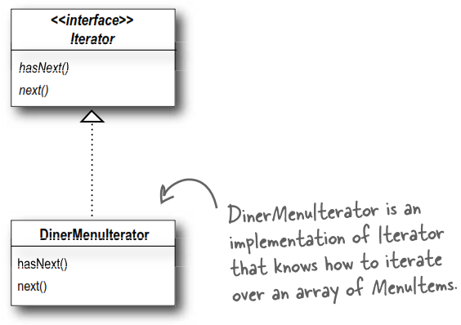

With the iterator, the implementation for getting items in PancakeHouseMenu and Diner menu will look like this:

// Get items in PancakeHouseMenu

Iterator iterator = breakfastMenu.createIterator();

while (iterator.hasNext()) {

MenuItem menuItem = (MenuItem)iterator.next();

}

// Get items in DinerMenu

Iterator iterator = lunchMenu.createIterator();

while (iterator.hasNext()) {

MenuItem menuItem = (MenuItem)iterator.next();

}

Once we have this interface, we can implement iterators for any kind of collection of objects: arrays, lists, hashtables, ...

Now the overall class diagram for our project will look like this. It actually has one weak point, can you spot it?

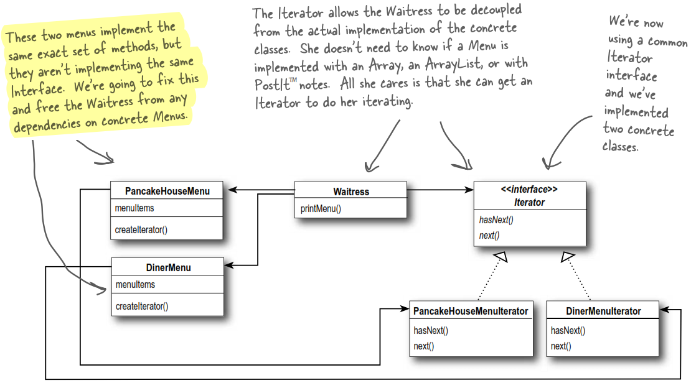

Re-implementing Diner menu with Iterator:

public interface Iterator

{

boolean hasNext();

Object next();

}

public class DinerMenuIterator implements Iterator

{

MenuItem[] items;

int position = 0;

public DinerMenuIterator(MenuItem[] items) {

this.items = items;

}

public Object next() {

MenuItem menuItem = items[position];

position = position + 1;

return menuItem;

}

public boolean hasNext() {

if (position >= items.length || items[position] == null) {

return false;

} else {

return true;

}

}

}

public class DinerMenu implements Menu

{

static ﬁnal int MAX_ITEMS = 6;

int numberOfItems = 0;

MenuItem[] menuItems;

// constructor here

// addItem here

~~public MenuItem[] getMenuItems() {~~

~~return menuItems;~~

~~}~~

public Iterator createIterator() {

return new DinerMenuIterator(menuItems);

}

// other menu methods here

}

Fixing the Waitress code:

public class Waitress

{

PancakeHouseMenu pancakeHouseMenu;

DinerMenu dinerMenu;

public Waitress(PancakeHouseMenu pancakeHouseMenu, DinerMenu dinerMenu) {

this.pancakeHouseMenu = pancakeHouseMenu;

this.dinerMenu = dinerMenu;

}

public void printMenu() {

Iterator pancakeIterator = pancakeHouseMenu.createIterator();

printMenu(pancakeIterator);

Iterator dinerIterator = dinerMenu.createIterator();

printMenu(dinerIterator);

}

private void printMenu(Iterator iterator) {

while (iterator.hasNext()) {

MenuItem menuItem = (MenuItem)iterator.next();

System.out.print(menuItem.getName() + , );

System.out.print(menuItem.getPrice() + -- );

System.out.println(menuItem.getDescription());

}

}

// other methods here

}

Let’s compare this new design with the previous one:

|  |  |
| --- | --- |
| **Hard-to-maintain Waitress** | **Iterator-powered Waitress** |
| The menus are not well encapsulated. We can see the Diner is using an Array and the Pancake House an ArrayList. | The menus are encapsulated. The Waitress has no idea how the Menus hold their collection of menu items. |
| We need two loops to iterate through the menu items. | All we need is a loop that polymorphically handles any  collection of items as long as it implements Iterator. |
| The Waitress is bound to concrete classes (MenuItem[] and ArrayList). | The Waitress uses an interface (Iterator). |

### Best Design

As described in the previous class diagram, the interfaces of PancakeHouseMenu and DinerMenu are exactly the same, but we haven’t deﬁned a common interface for them. It’s time to make thing better by helping Waitress can refer to each menu object using the interface rather than the concrete class. In other words, we’re reducing the dependency between the Waitress and the concrete classes by “programming to an interface, not an implementation.”

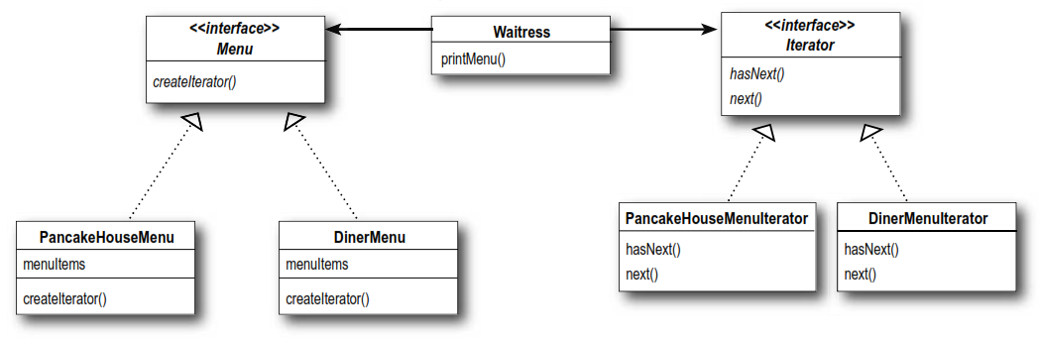

## Iterator Design Pattern

The Iterator Pattern provides a way to access the elements of an aggregate object sequentially without exposing its underlying implementation.

Back to our project, the pattern gives us various benefits:

* A way to step through the elements of an aggregate without having to know how things are represented under the covers.
* Once you have a uniform way of accessing the elements of all your aggregate objects, you can write polymorphic code that works with any of these aggregates – just like the printMenu(), which doesn’t care if the menu items are held in an Array or ArrayList (or anything else that can create an Iterator).
* The Iterator Pattern takes the responsibility of traversing elements and gives that responsibility to the iterator object, not the aggregate object. This not only keeps the aggregate interface and implementation simpler, it removes the responsibility for iteration from the aggregate and keeps the aggregate focused on the things it should be focused on (managing a collection of objects), not on iteration.

**QAs:**

**Q**: I’ve heard about “internal” iterators and “external” iterators. What are they? Which kind did we implement in the example?

* We implemented an external iterator which means that the client controls the iteration by calling next() to get the next element.

An internal iterator is controlled by the iterator itself. In that case, because it’s the iterator that’s stepping through the elements, you have to tell the iterator what to do with those elements as it goes through them. That means you need a way to pass an operation to an iterator. Internal iterators are less flexible that external iterators because the client doesn’t have control of the iteration. However, some might argue that they are easier to use because you just hand them an operation and tell them to iterate, and they do all the work for you.

**Q**: Who defines the ordering of the iteration in a collection like Hashtable, which are inherently unordered?

* Iterators imply no ordering. The underlying collections may be unordered as in Hashtable or in a bag; they may even contain duplicates. So ordering is related to both the properties of the underlying collection and to the implementation. In general, you should make no assumptions about ordering unless the Collection documentation indicates otherwise.

**Q**: You said we can write “polymorphic code” using an iterator; can you explain that more?

* When we write methods that take Iterators as parameters, we are using polymorphic iteration. That means we are creating code that can iterate over any collection as long as it supports Iterator. We don’t care about how the collection is implemented, we can still write code to iterate over it.

**Tip:**

In Java 5 they’ve added support for iterating over collections so that you don’t even have to ask for an iterator.

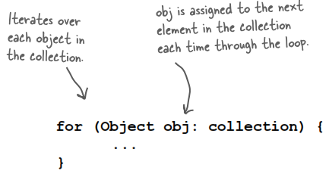

Here’s how you iterate over an ArrayList using for/in:

ArrayList items = new ArrayList();

items.add(new MenuItem("Pancakes", "delicious pancakes", true, 1.59);

items.add(new MenuItem("Wafﬂes", "yummy wafﬂes", true, 1.99);

items.add(new MenuItem("Toast", "perfect toast", true, 0.59);

for (MenuItem item: items) {

System.out.println("Breakfast item: " + item);

}

## Single Responsibility Principle

What if we allowed our aggregates to implement their internal collections and related operations, and the iteration methods? No, it’s a bad idea!

Why? When we allow a class to not only take care of its own business (managing some kind of aggregate) but also take on more responsibilities (like iteration), then we’ve given the class TWO reasons to change. It can change if the collection changes in some way, and it can change if the way we iterate changes. Having two ways to change increases the probability the class will change in the future, and when it does, it’s going to affect two aspects of your design.

The solution? The principle below guides us to assign each responsibility to one class, and only one class.

**Design Principle 9** (Single Responsibility): A class should have only one reason to change.

*You might not know!*

*Cohesion* is a term you’ll hear used as a measure of how closely a class or a module supports single responsibility. It’s a more general concept than the Single Responsibility principle, but the two are closely related.

A module or class has high cohesion when it is designed around a set of related functions. By contrast, it has low cohesion when it is designed around a set of unrelated functions.

# Composite Design Pattern

## Project and Solution

Same project as Iterator design pattern, but this time, they want to add a dessert submenu. Now we have to support not only multiple menus, but menus within menus.

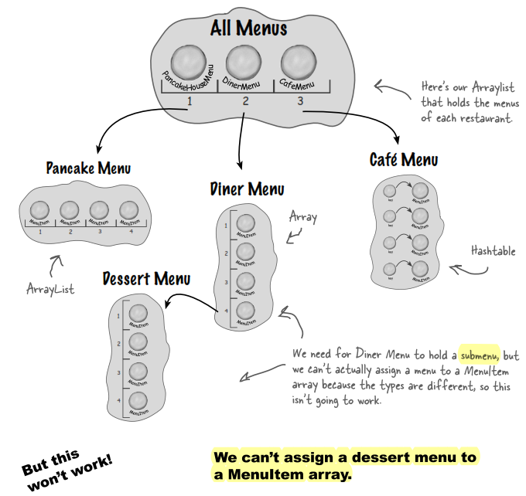

Basically, our project should have following output:

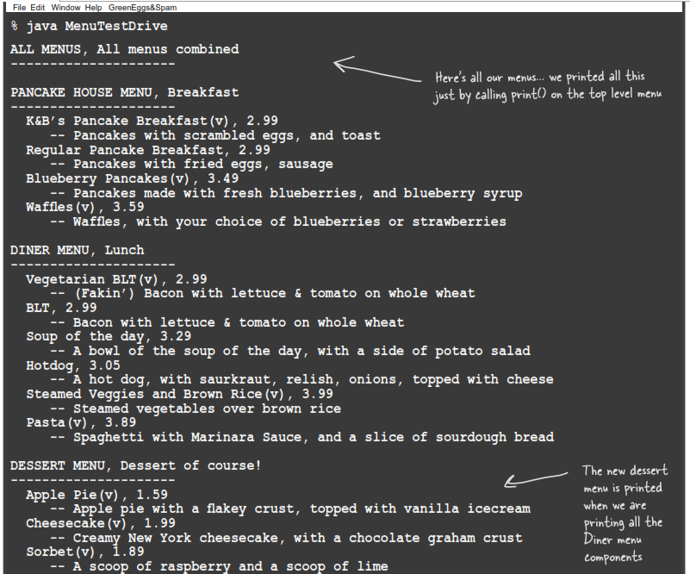

We’re going to need a new design:

* We need some kind of a tree-shaped structure that will accommodate menus, submenus and menu items.
* We need a way to traverse the items in each menu that is at least as convenient as what we are doing now with iterators.

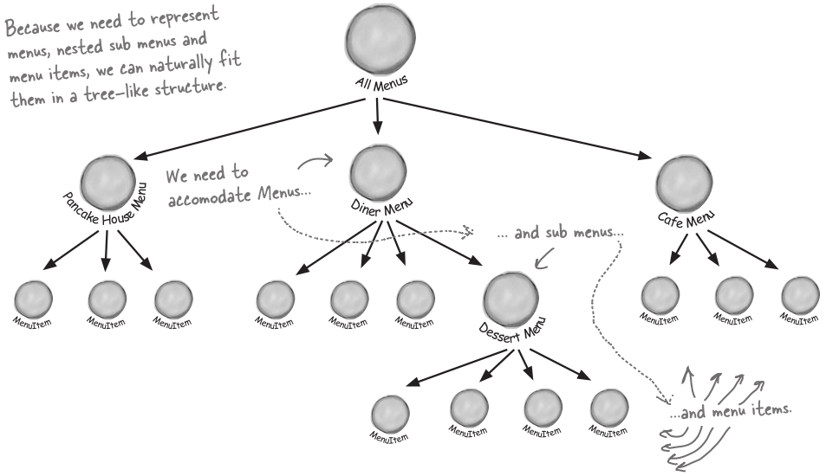

### Good Design

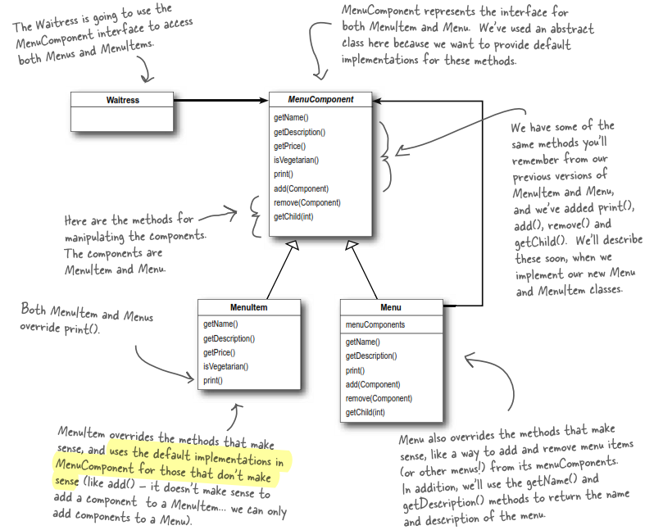

The implementation is as follows:

// Java code

public abstract class MenuComponent

{

// Because leaves and nodes have different roles

// we can't always deﬁne a default implementation that makes sense.

// Sometimes the best you can do is to throw a runtime exception.

public void add(MenuComponent menuComponent) {

throw new UnsupportedOperationException();

}

public void remove(MenuComponent menuComponent

throw new UnsupportedOperationException();

}

public MenuComponent getChild(int i) {

throw new UnsupportedOperationException();

}

public String getName() {

throw new UnsupportedOperationException();

}

public String getDescription() {

throw new UnsupportedOperationException();

}

public double getPrice() {

throw new UnsupportedOperationException();

}

public boolean isVegetarian() {

throw new UnsupportedOperationException();

}

public void print() {

throw new UnsupportedOperationException();

}

}

public class MenuItem extends MenuComponent

{

String name;

String description;

boolean vegetarian;

double price;

public MenuItem(String name,

String description,

boolean vegetarian,

double price)

{

this.name = name;

this.description = description;

this.vegetarian = vegetarian;

this.price = price;

}

public String getName() {

return name;

}

public String getDescription() {

return description;

}

public double getPrice() {

return price;

}

public boolean isVegetarian() {

return vegetarian;

}

public void print() {

System.out.print(" " + getName());

if (isVegetarian()) {

System.out.print("(v)");

}

System.out.println(", " + getPrice());

System.out.println(" -- " + getDescription());

}

}

public class Menu extends MenuComponent

{

ArrayList menuComponents = new ArrayList();

String name;

String description;

public Menu(String name, String description) {

this.name = name;

this.description = description;

}

public void add(MenuComponent menuComponent) {

menuComponents.add(menuComponent);

}

public void remove(MenuComponent menuComponent) {

menuComponents.remove(menuComponent);

}

public MenuComponent getChild(int i) {

return (MenuComponent)menuComponents.get(i);

}

public String getName() {

return name;

}

public String getDescription() {

return description;

}

public void print() {

System.out.print("\n" + getName());

System.out.println(", " + getDescription());

System.out.println("---------------------");

}

}

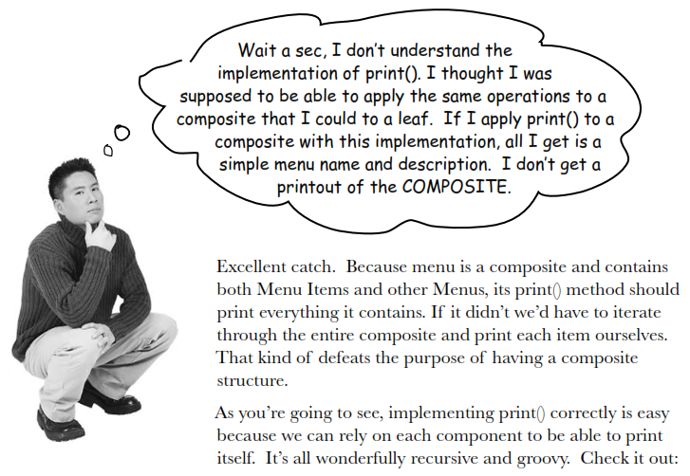

Fixing the print() method:

public class Menu extends MenuComponent

{

ArrayList menuComponents = new ArrayList();

String name;

String description;

// constructor code here

// other methods here

public void print() {

System.out.print("\n" + getName());

System.out.println(", " + getDescription());

System.out.println("---------------------");

Iterator iterator = menuComponents.iterator();

while (iterator.hasNext()) {

MenuComponent menuComponent =

(MenuComponent)iterator.next();

menuComponent.print();

}

}

}

Next, implement the client:

public class Waitress

{

MenuComponent allMenus;

public Waitress(MenuComponent allMenus) {

this.allMenus = allMenus;

}

public void printMenu() {

allMenus.print();

}

}

Finally, the test drive:

public class MenuTestDrive

{

public static void main(String args[]) {

// Create menu here

MenuComponent pancakeHouseMenu =

new Menu("PANCAKE HOUSE MENU", "Breakfast");

MenuComponent dinerMenu =

new Menu("DINER MENU", "Lunch");

MenuComponent dessertMenu =

new Menu("DESSERT MENU", "Dessert of course!");

// Add menu here

MenuComponent allMenus = new Menu("ALL MENUS", "All menus combined");

allMenus.add(pancakeHouseMenu);

allMenus.add(dinerMenu);

// Add submenu here

dinerMenu.add(dessertMenu);

// Add menu items here

dinerMenu.add(new MenuItem(

"Pasta",

"Spaghetti with Marinara Sauce, and a slice of sourdough bread",

true,

3.89));

dessertMenu.add(new MenuItem(

"Apple Pie",

"Apple pie with a ﬂakey crust, topped with vanilla icecream",

true,

1.59));

// Print menus, submenus and menu items

Waitress waitress = new Waitress(allMenus);

waitress.printMenu();

}

}

## Composite Design Pattern

Composite Pattern allows you to compose objects into tree structures to represent part-whole hierarchies. It lets clients treat individual objects and compositions of objects uniformly.

Let’s think about this in terms of our menus: this pattern gives us a way to create a tree structure that can handle a nested group of menus and menu items in the same structure. This way, we **create a part-whole hierarchy; that is, a tree of objects made of parts (menus and menu items) but can be treated as a whole**.

We can use this pattern to treat "individual objects and compositions uniformly." What does that mean? It means if we have a tree structure of menus, submenus, and perhaps subsubmenus along with menu items, then any menu is a "composition" because it can contain both other menus and menu items. The individual objects are just the menu items – they don’t hold other objects.

As you’ll see, using a design following the Composite Pattern is going to allow us to write some simple code that can apply the same operation (like printing) over the entire menu structure.

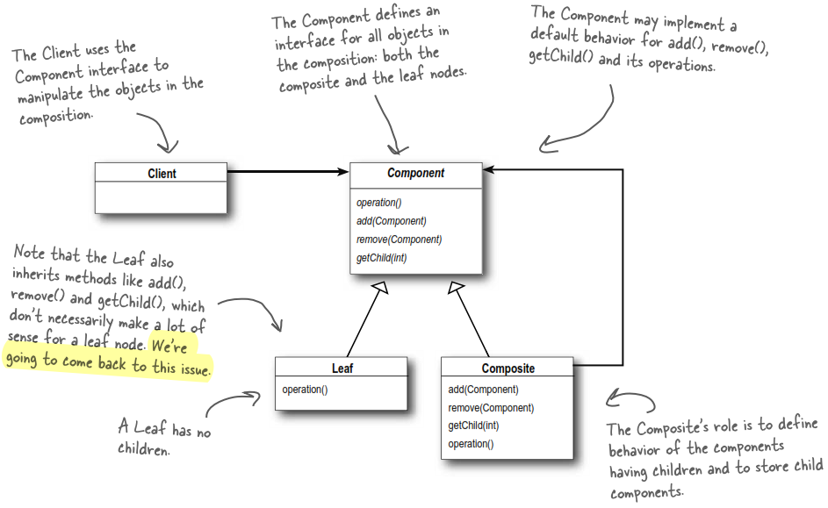

**Conversation:**

*HeadFirst*: What do you mean by whole-part relationships?

*Composite*: Imagine a GUI where you’ll often ﬁnd a top-level component (like a Frame or a Panel), containing other components (like menus, text panes, scrollbars and buttons). So your GUI consists of several parts, but when you display it, you generally think of it as a whole. You tell the top-level component to display, and count on that component to display all its parts. We call the components that contain other components as composite objects, and components that don’t contain other components as leaf objects.

*HeadFirst*: Is that what you mean by treating the objects uniformly? Having common methods you can call on composites and leaves?

*Composite*: Right. I can tell a composite object to display or a leaf object to display and they will do the right thing. The composite object will display by telling all its components to display.

*HeadFirst*: That implies that every object has the same interface. What if you have objects in your composite that do different things?

*Composite*: Well, in order for the composite to work transparently to the client, you must implement the same interface for all objects in the composite. Otherwise, the client has to worry about which interface each object is implementing, which kind of defeats the purpose. Obviously that means that at times you’ll have objects for which some of the method calls don’t make sense.

*HeadFirst*: So how do you handle that?

*Composite*: Well there’s a couple of ways to handle it; sometimes you can just do nothing, or return null or false – whatever makes sense in your application. Other times you’ll want to be more proactive and throw an exception.

*HeadFirst*: But if the client doesn’t know which kind of object they’re dealing with, how would they ever know which calls to make without checking the type?

*Composite*: If you’re a little creative you can structure your methods so that the default implementations do something that does make sense. For instance, if the client is calling getChild(), on the composite this makes sense. And it makes sense on a leaf too, if you think of the leaf as an object with no children.

*HeadFirst*: Ah... smart. But, I’ve heard some clients are so worried about this issue, that they require separate interfaces for different objects so they aren’t allowed to make nonsensical method calls. Is that still the Composite Pattern?

*Composite*: Yes. **It’s a much safer version of the Composite Pattern, but it requires the client to check the type of every object before making a call so the object can be cast correctly**.

*HeadFirst*: Do children ever point back up to their parents?

*Composite*: Yes, a component can have a pointer to a parent to make traversal of the structure easier. And, if you have a reference to a child, and you need to delete it, you’ll need to get the parent to remove the child. Having the parent reference makes that easier too.

*HeadFirst*: There’s really quite a lot to consider in your implementation. Are there other issues we should think about when implementing the Composite Pattern?

*Composite*: Actually there is the ordering of children. What if you have a composite that needs to keep its children in a particular order? Then you’ll need a more sophisticated management scheme for adding and removing children, and you’ll have to be careful about how you traverse the hierarchy.

*HeadFirst*: A good point I hadn’t thought of.

*Composite*: And did you think about caching? Sometimes, if the composite structure is complex or expensive to traverse, it’s helpful to implement caching of the composite nodes. For instance, if you are constantly traversing a composite and all its children to compute some result, you could implement a cache that stores the result temporarily to save traversals.

*HeadFirst*: Well, there’s a lot more to the Composite Patterns than I ever would have guessed. Before we wrap this up, one more question: What do you consider your greatest strength?

*Composite*: I have to say simplifying life for my clients. **My clients don’t have to worry about whether they’re dealing with a composite object or a leaf object, so they don’t have to write if statements everywhere to make sure they’re calling the right methods on the right objects**. Often, they can make one method call and execute an operation over an entire structure.

*HeadFirst*: That does sound like an important beneﬁt. There’s no doubt you’re a useful pattern to have around for collecting and managing objects.

*You might not know!*

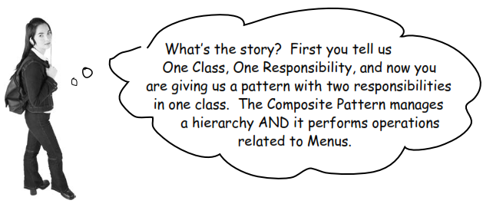

We could say that **the Composite Pattern trades the Single Responsibility design principle for transparency**. What’s transparency? Well, by allowing the Component interface to contain the child management operations and the leaf operations, a client can treat both composites and leaf nodes uniformly; so whether an element is a composite or leaf node becomes transparent to the client.

Now given we have both types of operations in the Component class, we lose a bit of safety because a client might try to do something inappropriate or meaningless on an element (like try to add a menu to a menu item). This is a design decision; we could take the design in the other direction and separate out the responsibilities into interfaces. This would make our design safe, in the sense that any inappropriate calls on elements would be caught at compile time or runtime, but we’d lose transparency and our code would have to use conditionals and the instanceof operator.

So, to return to your question, this is a classic case of tradeoff. We are guided by design principles, but we always need to observe the effect they have on our designs. Sometimes we purposely do things in a way that seems to violate the principle. In some cases, however, this is a matter of perspective; for instance, it might seem incorrect to have child management operations in the leaf nodes (like add(), remove() and getChild()), but then again you can always shift your perspective and see a leaf as a node with zero children.

# State Design Pattern

## Project and Solution

First we’re going to create a simple [**Gumball Machine**](https://www.youtube.com/watch?v=Q3ZeUNDg4fQ&ab_channel=JaredOwen). Then we’ll add some advanced features that conventional gumball machines do not have.

The state diagram of a simple gumball machine is as follows:

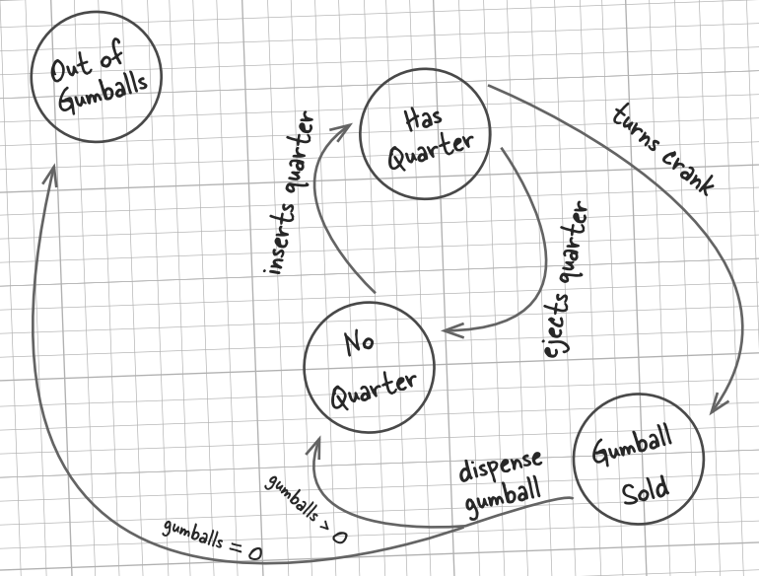

**Note**: Each circle is a state, and each arrow is a state transition. For every possible action we’ll have to check to see which state we’re in and act appropriately. Don’t forget that we could do nonsensical things, like try to eject the quarter when the gumball machine is in the "No Quarter" state, or insert two quarters.

### Bad Design

The following implementation uses a common technique: modeling state within an object by creating an instance variable to hold the state values and writing conditional code within our methods to handle the various states.

// Java code

public class GumballMachine

{

// Four states in Mighty Gumball’s state diagram

ﬁnal static int SOLD_OUT = 0;

ﬁnal static int NO_QUARTER = 1;

ﬁnal static int HAS_QUARTER = 2;

ﬁnal static int SOLD = 3;

int state = SOLD_OUT;

int coinCnt = 0;

public GumballMachine(int coinCnt)

{

this.coinCnt = coinCnt;

if (coinCnt > 0) {

state = NO_QUARTER;

}

}

public void insertQuarter()

{

if (state == HAS_QUARTER) {

System.out.println("You can't insert another quarter");

} else if (state == NO_QUARTER) {

state = HAS_QUARTER;

System.out.println("You inserted a quarter");

} else if (state == SOLD_OUT) {

System.out.println("You can't insert a quarter, the machine is sold out");

} else if (state == SOLD) {

System.out.println("Please wait, we're already giving you a gumball");

}

}

public void ejectQuarter()

{

if (state == HAS_QUARTER) {

System.out.println("Quarter returned");

state = NO_QUARTER;

} else if (state == NO_QUARTER) {

System.out.println("You haven't inserted a quarter");

} else if (state == SOLD) {

System.out.println("Sorry, you already turned the crank");

} else if (state == SOLD_OUT) {

System.out.println("You can't eject, you haven't inserted a quarter yet");

}

}

public void turnCrank()

{

if (state == SOLD) {

System.out.println("Turning twice doesn't get you another gumball!");

} else if (state == NO_QUARTER) {

System.out.println("You turned but there's no quarter");

} else if (state == SOLD_OUT) {

System.out.println("You turned, but there are no gumballs");

} else if (state == HAS_QUARTER) {

System.out.println("You turned...");

state = SOLD;

dispense();

}

}

public void dispense()

{

if (state == SOLD) {

System.out.println("A gumball comes rolling out the slot");

coinCnt = coinCnt - 1;

if (coinCnt == 0) {

System.out.println("Oops, out of gumballs!");

state = SOLD_OUT;

} else {

state = NO_QUARTER;

}

} else if (state == NO_QUARTER) {

System.out.println("You need to pay ﬁrst");

} else if (state == SOLD_OUT) {

System.out.println("No gumball dispensed");

} else if (state == HAS_QUARTER) {

System.out.println("No gumball dispensed");

}

}

// other methods here like toString() and reﬁll()

}

public class GumballMachineTestDrive

{

public static void main(String[] args)

{

/*

Inventory: 5 gumballs

Machine is waiting for quarter

*/

GumballMachine gumballMachine = new GumballMachine(5);

System.out.println(gumballMachine);

/* Output:

You inserted a quarter

You turned...

A gumball comes rolling out the slot

Inventory: 4 gumballs

Machine is waiting for quarter

*/

gumballMachine.insertQuarter();

gumballMachine.turnCrank();

System.out.println(gumballMachine);

/* Output:

You inserted a quarter

Quarter returned

You turned but there's no quarter

Inventory: 4 gumballs

Machine is waiting for quarter

*/

gumballMachine.insertQuarter();

gumballMachine.ejectQuarter();

gumballMachine.turnCrank();

System.out.println(gumballMachine);

/* Output:

You inserted a quarter

You turned...

A gumball comes rolling out the slot

You inserted a quarter

You turned...

A gumball comes rolling out the slot

You haven't inserted a quarter

Inventory: 2 gumballs

Machine is waiting for quarter

*/

gumballMachine.insertQuarter();

gumballMachine.turnCrank();

gumballMachine.insertQuarter();

gumballMachine.turnCrank();

gumballMachine.ejectQuarter();

System.out.println(gumballMachine);

/* Output:

You inserted a quarter

You can't insert another quarter

You turned...

A gumball comes rolling out the slot

You inserted a quarter

You turned...

A gumball comes rolling out the slot

Oops, out of gumballs!

You can't insert a quarter, the machine is sold out

You turned, but there are no gumballs

Inventory: 0 gumballs

Machine is sold out

*/

gumballMachine.insertQuarter();

gumballMachine.insertQuarter();

gumballMachine.turnCrank();

gumballMachine.insertQuarter();

gumballMachine.turnCrank();

gumballMachine.insertQuarter();

gumballMachine.turnCrank();

System.out.println(gumballMachine);

}

}

The above design is poor because:

* We haven’t encapsulated anything that varies here.
* A class have too many reasons to change.
* Not very object-oriented.
* State transitions aren’t explicit, but buried in the middle of a bunch of conditional statements.
* …

As a result, it’s difficult for us to maintain when a change request comes, such as:



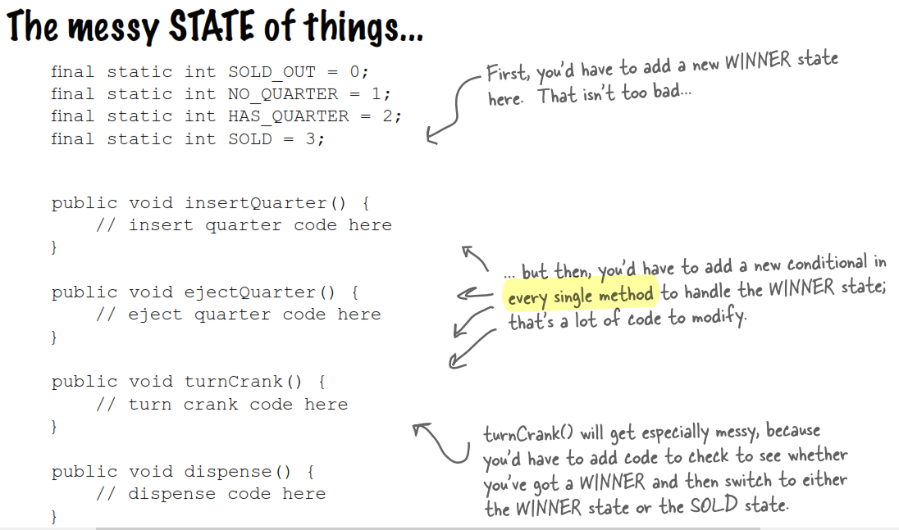

### Good Design

To fix the above poor design, we need to localize the behavior for each state so that if we make changes to one state, we don’t run the risk of messing up the other code. In other words, we’re going to rework it to **encapsulate state objects in their own classes** and then delegate to the current state when an action occurs.

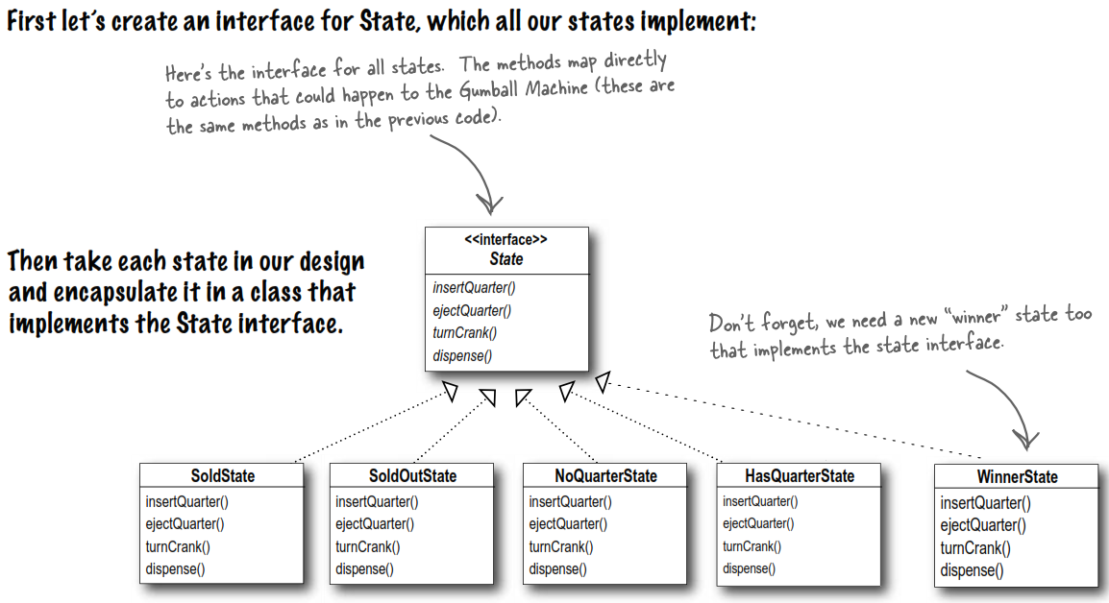

The implementation is as follows:

public interface State

{

// Method prototypes

}

public class NoQuarterState implements State

{

GumballMachine gumballMachine;

public NoQuarterState(GumballMachine gumballMachine) {

this.gumballMachine = gumballMachine;

}

public void insertQuarter() {

System.out.println("You inserted a quarter");

gumballMachine.setState(gumballMachine.getHasQuarterState());

}

public void ejectQuarter() {

System.out.println("You haven't inserted a quarter");

}

public void turnCrank() {

System.out.println("You turned, but there's no quarter");

}

public void dispense() {

System.out.println("You need to pay ﬁrst");

}

}

public class HasQuarterState implements State

{

Random randomWinner = new Random(System.currentTimeMillis());

GumballMachine gumballMachine;

public HasQuarterState(GumballMachine gumballMachine) {

this.gumballMachine = gumballMachine;

}

public void insertQuarter() {

System.out.println("You can't insert another quarter");

}

public void ejectQuarter() {

System.out.println("Quarter returned");

gumballMachine.setState(gumballMachine.getNoQuarterState());

}

public void turnCrank() {

System.out.println("You turned...");

int winner = randomWinner.nextInt(10);

if ((winner == 0) && (gumballMachine.getCointCount() > 1)) {

gumballMachine.setState(gumballMachine.getWinnerState());

} else {

gumballMachine.setState(gumballMachine.getSoldState());

}

}

public void dispense() {

System.out.println("No gumball dispensed");

}

}

public class SoldState implements State

{

// Constructor and instance variables here

public void insertQuarter() {

System.out.println("Please wait, we're already giving you a gumball");

}

public void ejectQuarter() {

System.out.println("Sorry, you already turned the crank");

}

public void turnCrank() {

System.out.println("Turning twice doesn't get you another gumball!");

}

public void dispense() {

gumballMachine.releaseBall();

if (gumballMachine.getCointCount() > 0) {

gumballMachine.setState(gumballMachine.getNoQuarterState());

} else {

System.out.println("Oops, out of gumballs!");

gumballMachine.setState(gumballMachine.getSoldOutState());

}

}

}

public class SoldOutState implements State

{

// Methods

}

public class WinnerState implements State

{

// instance variables and constructor

// insertQuarter error message

// ejectQuarter error message

// turnCrank error message

public void dispense() {

System.out.println("YOU'RE A WINNER! You get two gumballs for your quarter");

gumballMachine.releaseBall();

if (gumballMachine.getCointCount() == 0) {

gumballMachine.setState(gumballMachine.getSoldOutState());

} else {

gumballMachine.releaseBall();

if (gumballMachine.getCointCount() > 0) {

gumballMachine.setState(gumballMachine.getNoQuarterState());

} else {

System.out.println("Oops, out of gumballs!");

gumballMachine.setState(gumballMachine.getSoldOutState());

}

}

}

}

public class GumballMachine

{

// Instead of global variables, now we’re using objects for states

State soldOutState;

State noQuarterState;

State hasQuarterState;

State soldState;

State winnerState;

State state = soldOutState;

int cointCnt = 0;

public GumballMachine(int numberGumballs) {

soldOutState = new SoldOutState(this);

noQuarterState = new NoQuarterState(this);

hasQuarterState = new HasQuarterState(this);

soldState = new SoldState(this);

this.cointCnt = numberGumballs;

if (numberGumballs > 0) {

state = noQuarterState;

}

}

public void insertQuarter() {

state.insertQuarter();

}

public void ejectQuarter() {

state.ejectQuarter();

}

public void turnCrank() {

state.turnCrank();

state.dispense();

}

void setState(State state) {

this.state = state;

}

void releaseBall() {

System.out.println("A gumball comes rolling out the slot...");

if (cointCnt != 0) {

cointCnt = cointCnt - 1;

}

}

// More methods here including getters for each state...

}

public class GumballMachineTestDrive

{

public static void main(String[] args)

{

/* Output:

Mighty Gumball, Inc.

Java-enabled Standing Gumball Model #2004

Inventory: 5 gumballs

Machine is waiting for quarter

*/

GumballMachine gumballMachine = new GumballMachine(5);

System.out.println(gumballMachine);

/* Output:

You inserted a quarter

You turned...

YOU'RE A WINNER! You get two gumballs for your quarter

A gumball comes rolling out the slot...

A gumball comes rolling out the slot...

Mighty Gumball, Inc.

Java-enabled Standing Gumball Model #2004

Inventory: 3 gumballs

Machine is waiting for quarter

*/

gumballMachine.insertQuarter();

gumballMachine.turnCrank();

System.out.println(gumballMachine);

/* Output:

You inserted a quarter

You turned...

A gumball comes rolling out the slot...

You inserted a quarter

You turned...

YOU'RE A WINNER! You get two gumballs for your quarter

A gumball comes rolling out the slot...

A gumball comes rolling out the slot...

Oops, out of gumballs!

Mighty Gumball, Inc.

Java-enabled Standing Gumball Model #2004

Inventory: 0 gumballs

Machine is sold out

*/

gumballMachine.insertQuarter();

gumballMachine.turnCrank();

gumballMachine.insertQuarter();

gumballMachine.turnCrank();

System.out.println(gumballMachine);

}

}

This design is good because:

* Localizes the behavior of each state into its own class.
* Removes all the conditional statements which are difﬁcult to maintain.
* Closes each state for modiﬁcation, and yet left the Gumball Machine open to extension by adding new state classes.
* Creates a code base and class structure that maps much more closely to the state diagram and is easier to read and understand.

## State Design Pattern

State Pattern allows an object to alter its behavior when its internal state changes. The object will appear to change its class.

Definition explanation:

* First part: Because the pattern encapsulates state into separate classes and delegates to the object representing the current state, we know that **behavior changes along with the internal state**.
* Second part: If an object you’re using can completely change its behavior, then it appears to you that the object is actually instantiated from another class. In reality, however, you know that we are using composition to give the appearance of a class change by simply referencing different state objects.

State Pattern class diagram:

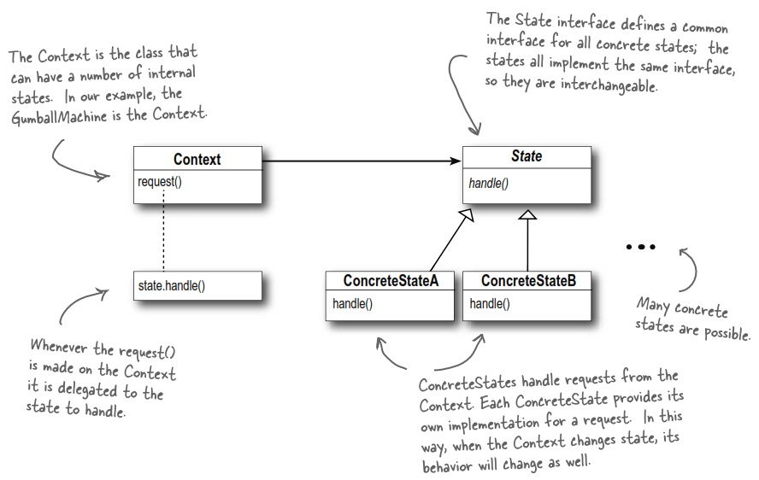

## Strategy vs State

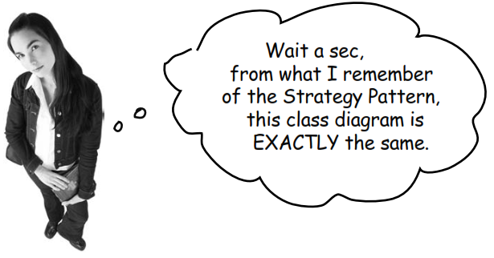

*Strategy*: Hey bro! You sound like you’ve just copied what I do. Think about it: I allow objects to incorporate different behaviors or algorithms through composition and delegation. You’re just copying me.

*State*: I admit that what we do is deﬁnitely related, but my intent is totally different than yours. And, the way I teach my clients to use composition and delegation is totally different.

*Strategy*: How so?

*State*: Think about how you work: you have a class you’re instantiating and you usually give it a strategy object that implements some behaviors. Like, in Chapter 1 you were handing out quack behaviors. Real ducks got a real quack, rubber ducks got a quack that squeaked.

*Strategy*: Yes!

*State*: Also, when my Context objects get created, I may tell them the state to start in, but then they change their own state over time.

*Strategy*: Hey, I can change behavior at runtime too; that’s what composition is all about!

*State*: Sure you can, but the way I work is built around discrete states; my Context objects change state over time according to some well deﬁned state transitions. In other words, **changing behavior is built in to my** scheme – it’s how I work!

*Strategy*: Well, I admit, I don’t encourage my objects to have a well-deﬁned set of transitions between states. In fact, I typically like to control what strategy my objects are using.

*State*: In general, think of you as a ﬂexible alternative to subclassing; if you use inheritance to deﬁne the behavior of a class, then you’re stuck with that behavior even if you need to change it. You can only change the behavior by composing with a different object. I’m different; by encapsulating the behaviors within state objects, I can simply change the state object in context to change its behavior.

# Proxy Design Pattern

## What Is Proxy?

Ever play *good cop*, *bad cop*? You’re the *good cop* and you provide all your services in a nice and friendly manner, but you don’t want everyone asking you for services, so you have the *bad cop* control access to you.

Another example is your credit card. It acts as a proxy for what is in your bank account. It can be used in place of cash, and provides a means of accessing that cash when required.

That’s what proxies do: **control and manage access to the object they are protecting**. There’re lots of ways in which proxies stand in for the objects they proxy.

## Types of Proxy?

**Protection Proxy**

If an application does not have access to some resource, then these proxies will talk to the objects in applications that have access to that resource and then get the result back.

**Virtual Proxy**

They provide some default and instant results if the real object is supposed to take some time to produce results. They initiate the operation on real objects and provide a default result to the application. Once the real object is done, they push the actual data to the client where it has provided dummy data earlier.

**Remote Proxy**

They represent the object located remotely. Talking to the real object might involve marshalling and unmarshalling of data. All that logic is encapsulated in the proxy and the client need not worry about them.

The remote proxy also ensures about security by installing the local code proxy (**stub**) in the client machine and then accessing the server with help of the remote code.

You might not know!

A **Stub** is a specific type of proxy used in remote communication. When you have distributed systems where objects or services reside on different machines or processes, the Stub acts as a representative or surrogate for the remote object. It provides a local interface that mimics the interface of the remote object, allowing the client to interact with it as if it were local.

When a client invokes a method on the Stub, the Stub is responsible for marshaling the method call and its parameters, sending them over the network or IPC mechanism, and forwarding the request to the actual remote object. Similarly, when the response is received, the Stub handles unmarshaling the response and returning it to the client.

**Smart Proxy**

A smart proxy provides additional layer of security by interposing specific actions when the object is accessed. An example can be to check if the real object is locked before it’s accessed to ensure that no other object can change it.

## Project and Solution

Project 1:

Some companies restrict website access. The proxy first checks the host you’re connecting to. If it’s not in the restricted list, it connects to the internet. Otherwise, it cannot be accessed.

This example is based on *Protection Proxy*.

With a proxy, we’ll design our program like that:

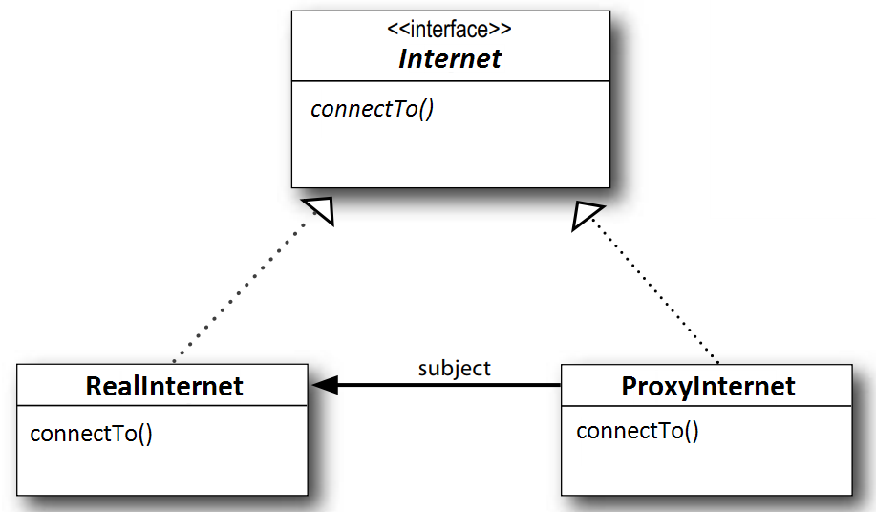

Clients interact with the *RealInternet* through the *ProxyInternet*. Because they both implement the same interface *Internet*, the *ProxyInternet* can be substituted anywhere the *Internet* can be used. The *ProxyInternet* also controls access to the *RealInternet*.

Project 2:

With project 1, but this time, we know that accessing to Internet might take a few minutes. During this waiting, we want something to display (e.g., text like "please wait …").

An easy way to achieve this is through a *Virtual Proxy*. That is we provide some instant results while the real thing is supposed to take some time to produce results.

## Proxy Design Pattern

The Proxy Pattern provides an object (called a proxy) that acts as a substitute for a real object to control access to that real object.

Following is class diagram of Proxy design pattern:

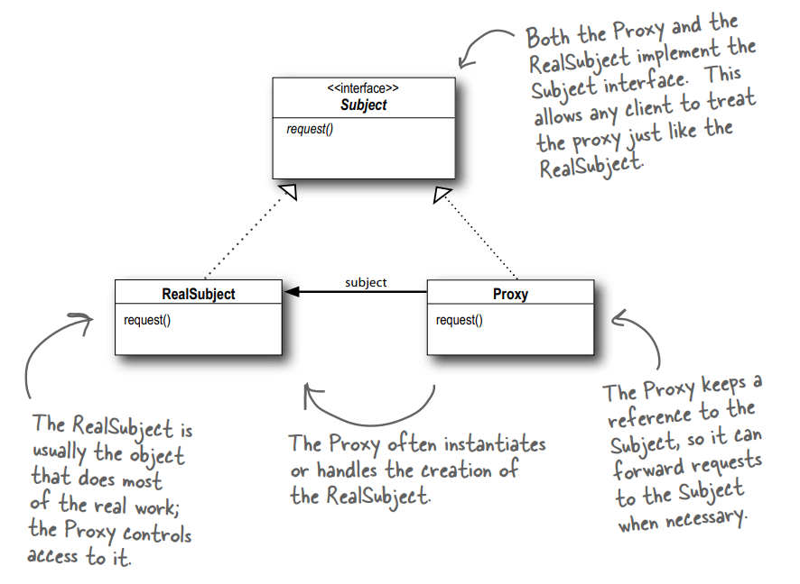

Note these terms:

* **Subject**: It’s the interface or abstract class that defines the common methods that both the *RealSubject* and the *Proxy* will implement.
* **Proxy**: It acts as a wrapper or surrogate for the *RealSubject*. It implements the same interface as the *Subject* and maintains a reference to the *RealSubject* object. It controls access to the *RealSubject* and may perform additional tasks before or after delegating the request to the *RealSubject*.

# Model-View-Controller (MVC)

## Project

MP3 player: You can use its UI to add new songs, manage playlists and rename tracks. The player takes care of maintaining a little database of songs. It’s also responsible for playing the songs; as it does, the UI is constantly updated with the current song title, running time, etc.

## Solution

Meet the MVC:

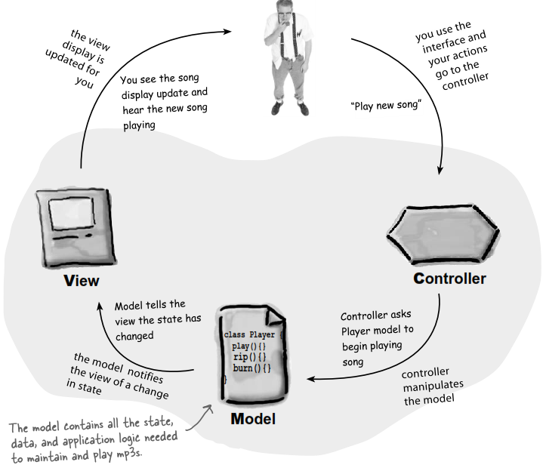

A closer look:

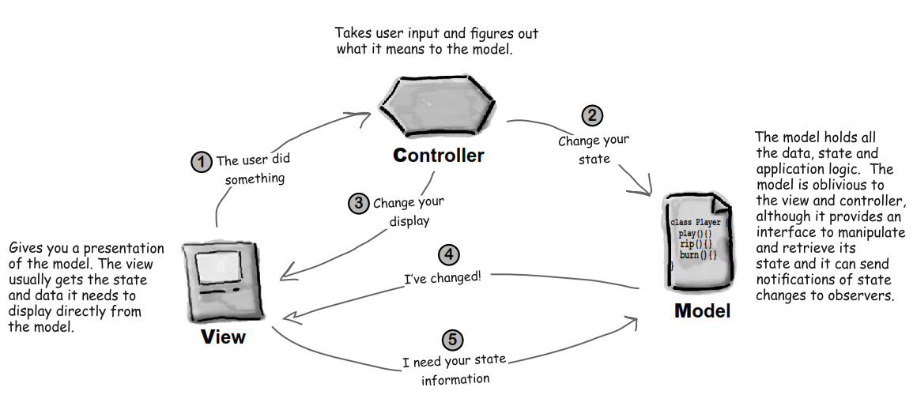

Look at MVC through pattern-colored class:

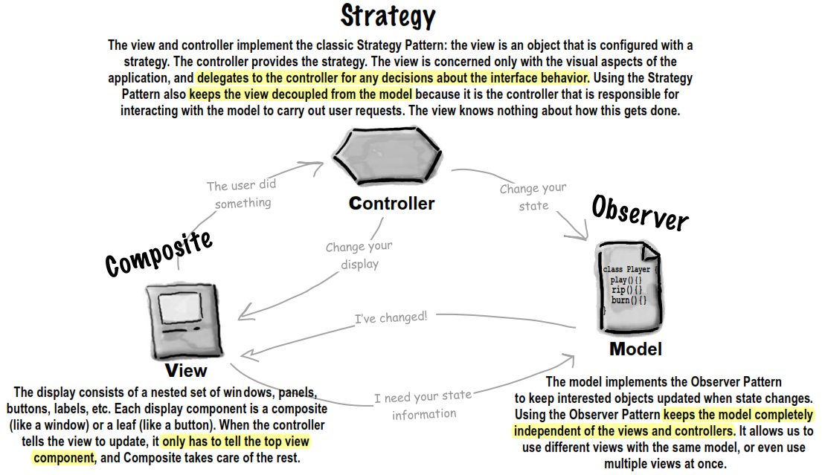

DJ application: page 572